**AMAZON S3 REPLICATION**

In AWS, **replication** can refer to various services and techniques used to duplicate data across different regions, availability zones, or systems for redundancy, scalability, and disaster recovery

**Amazon S3 Replication**

* **Cross-Region Replication (CRR):** Copies objects from one S3 bucket to another in a different AWS region. Used for disaster recovery, compliance, and low-latency access.
* **Same-Region Replication (SRR):** Copies objects within the same AWS region but different buckets. Used for backups, compliance, and keeping production and test environments in sync.

**Steps to Set Up S3 Replication**

1. **Create two S3 buckets** (one source and one destination).
2. **Enable Versioning** on both buckets.

* Go to the S3 console → Select the source bucket → "Properties" → Enable "Bucket Versioning."
* Repeat for the destination bucket.

1. Set up Replication Rule

* **Open the source bucket → Go to "Management" → Click "Create replication rule."**
* **Choose destination bucket and configure IAM role.**
* **Optionally filter objects by prefix or tags.**
* **Enable replication and save.**

1. Replication takes place automatically when new objects are uploaded.
2. Create a new bucket with the name **myoriginal-bucket.aws General purpose**, which is recommended for most use cases as it provides redundancy across multiple Availability Zones.

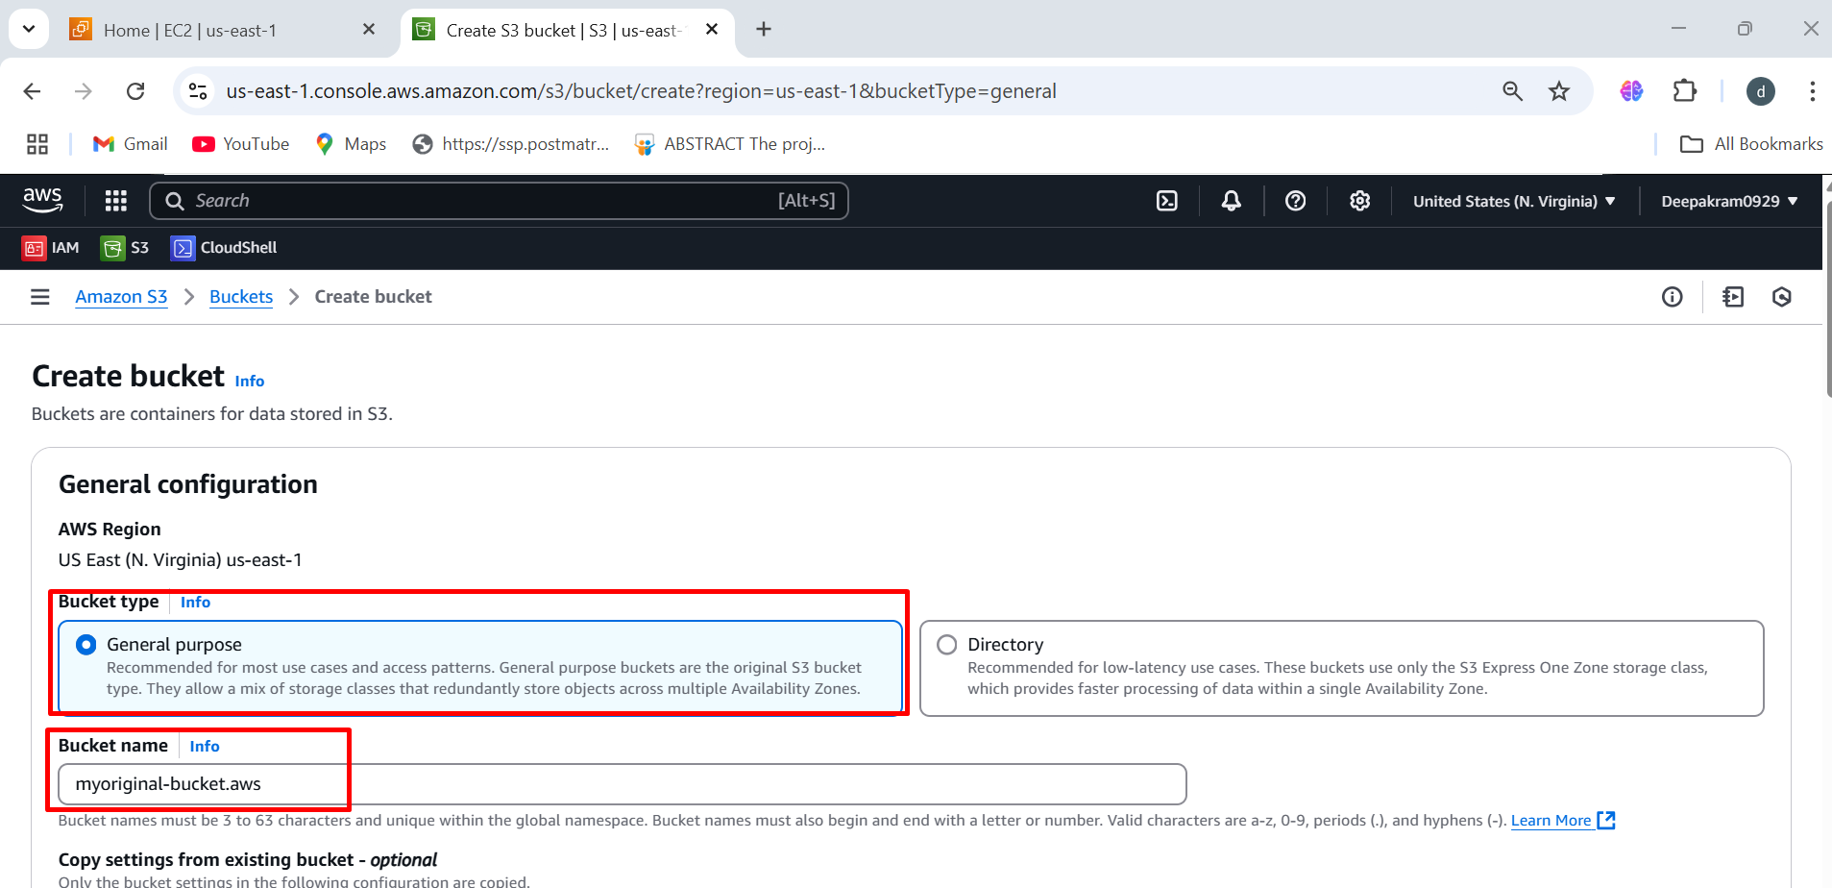

1. ACLs Disabled (Recommended) – Selected 🡪 Access to objects will be managed only using bucket policies and IAM policies, rather than Access Control Lists (ACLs).

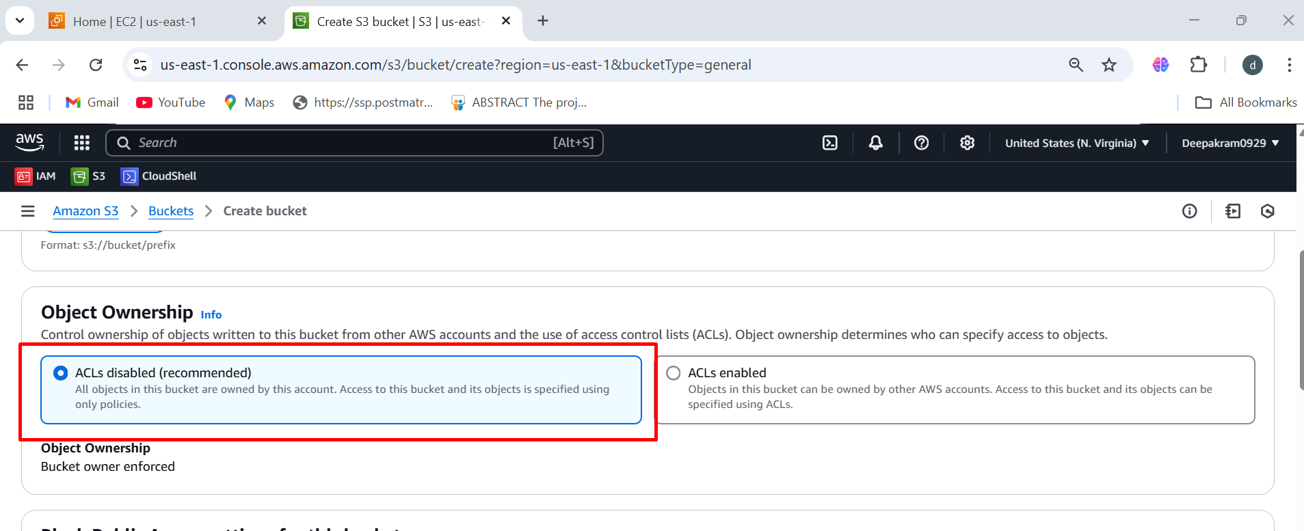

1. Enable the bucket versioning 🡪 click on create bucket

Versioning allows you to preserve, retrieve, and restore every version of every object stored in the bucket.

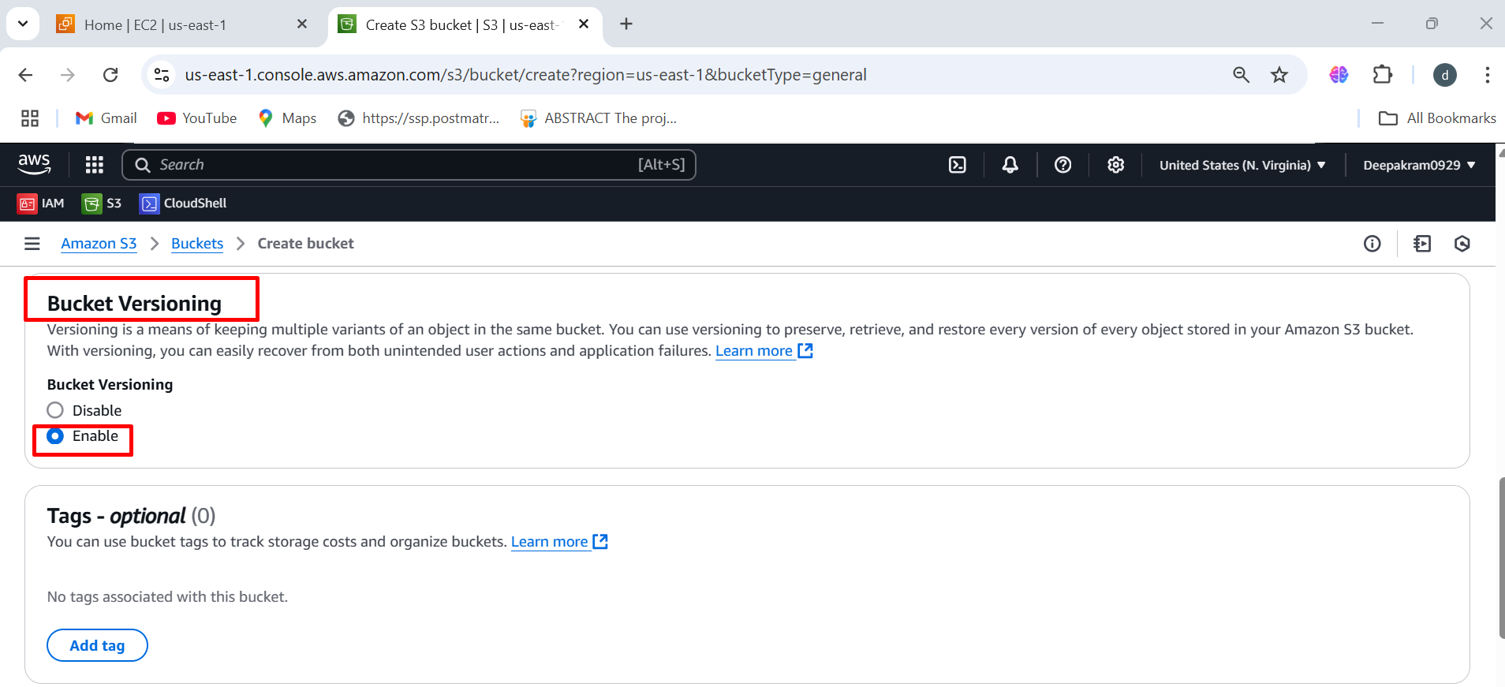

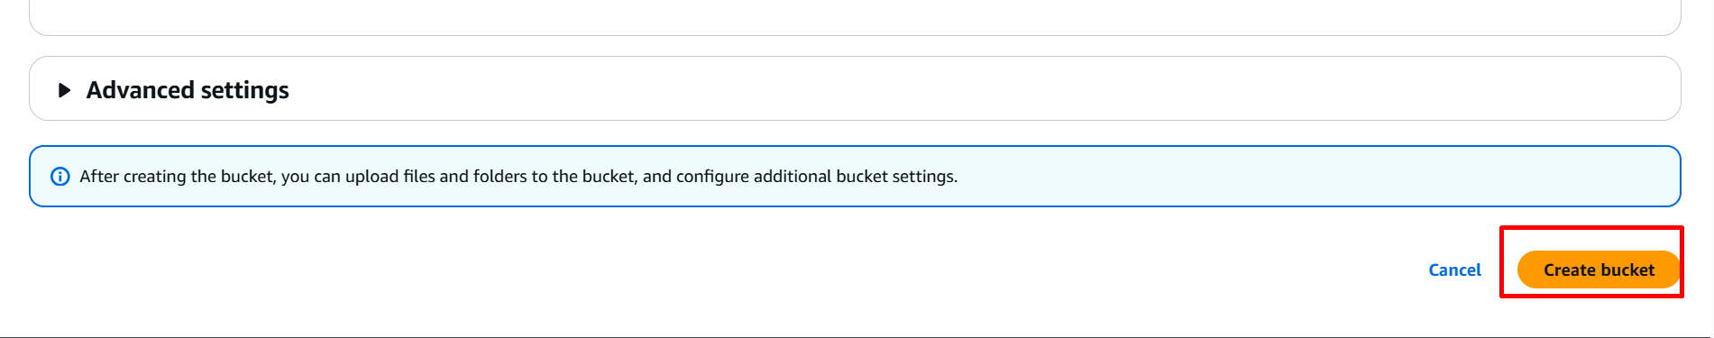

1. Follow the same steps to create new bucket 🡪 myreplication-bucket.aws

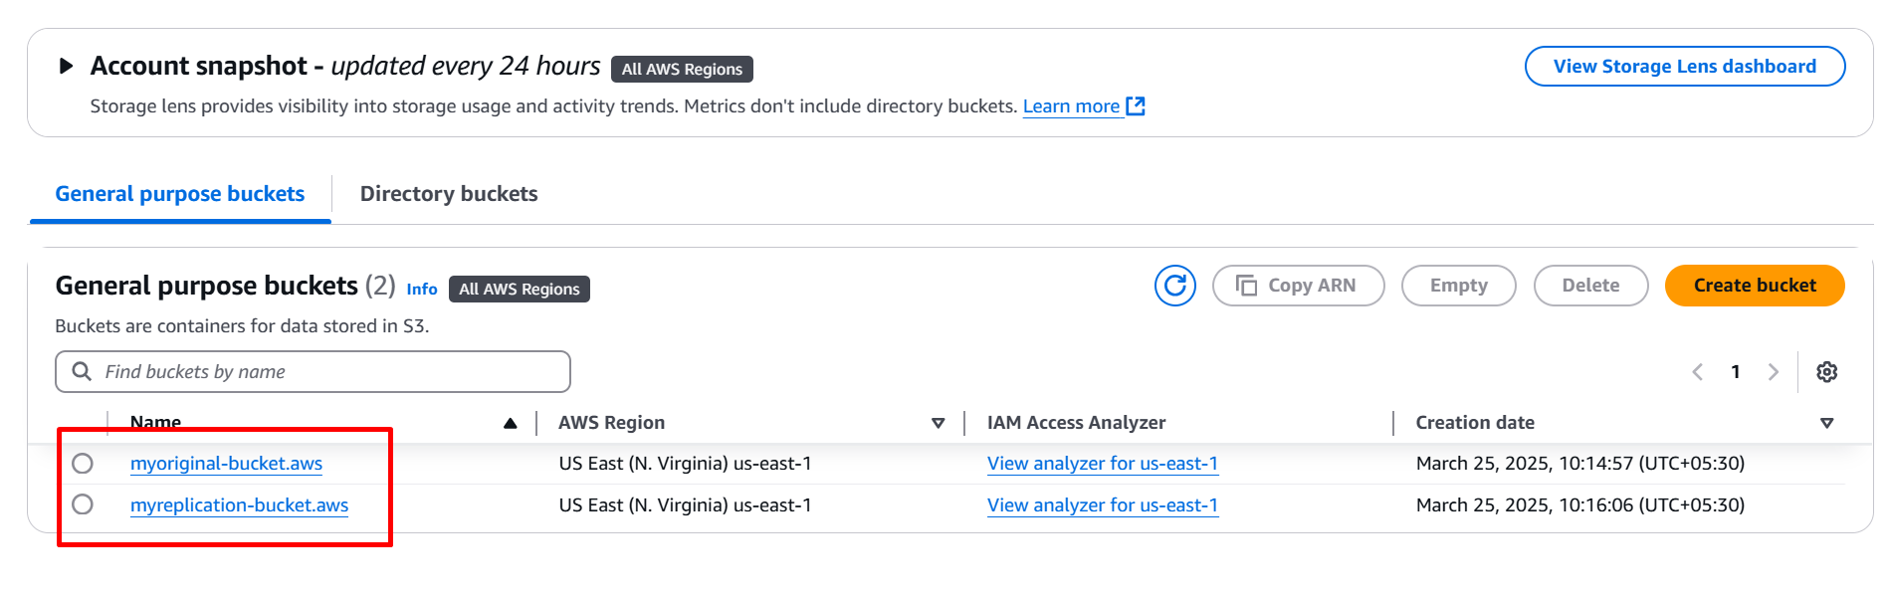

1. Click on myoriginal-bucket.aws

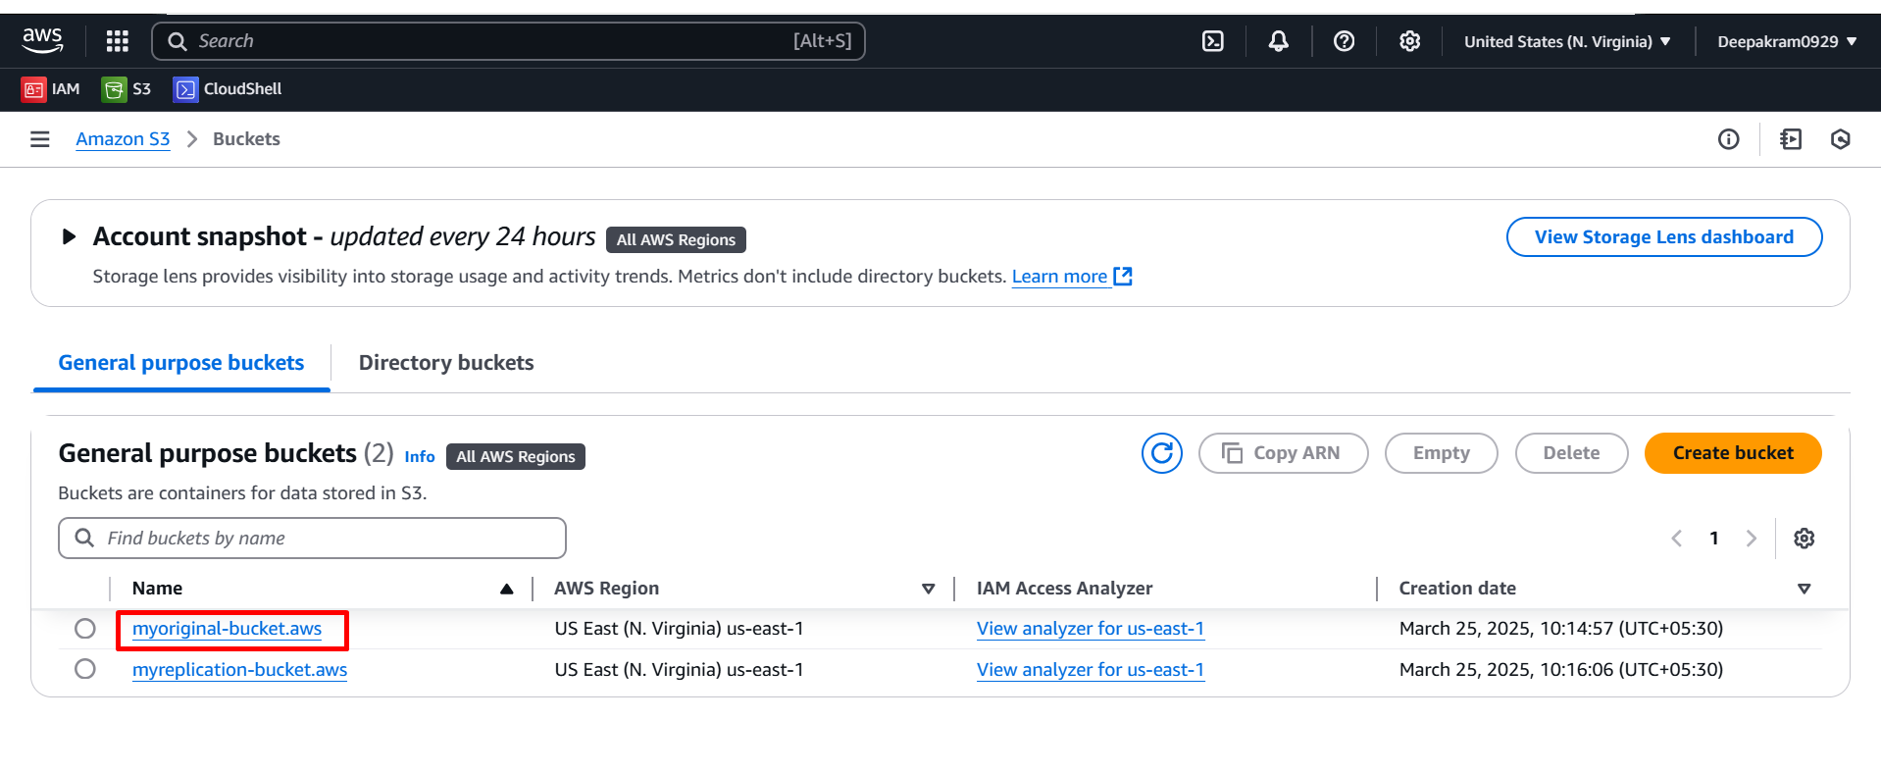

1. Click on properties 🡪 edit 🡪 enable bucket versioning 🡪 save

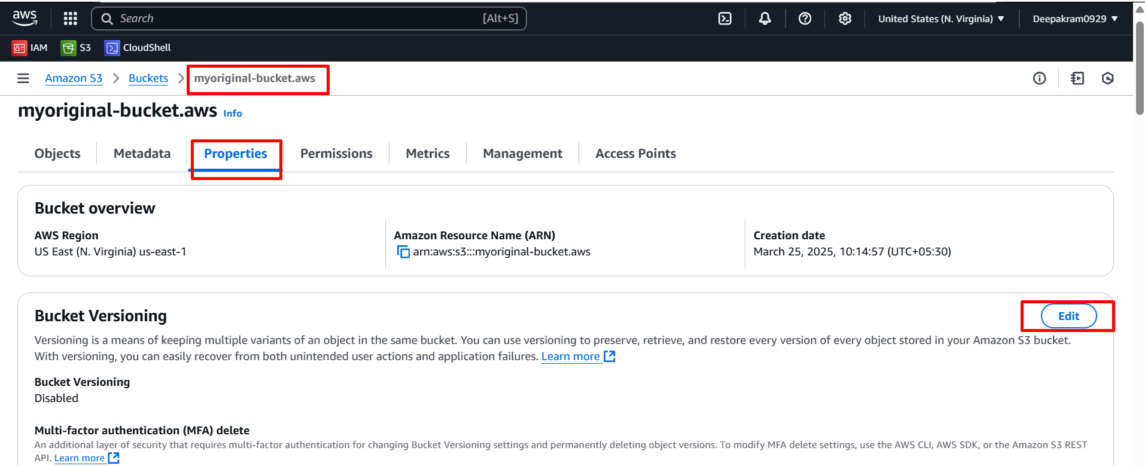

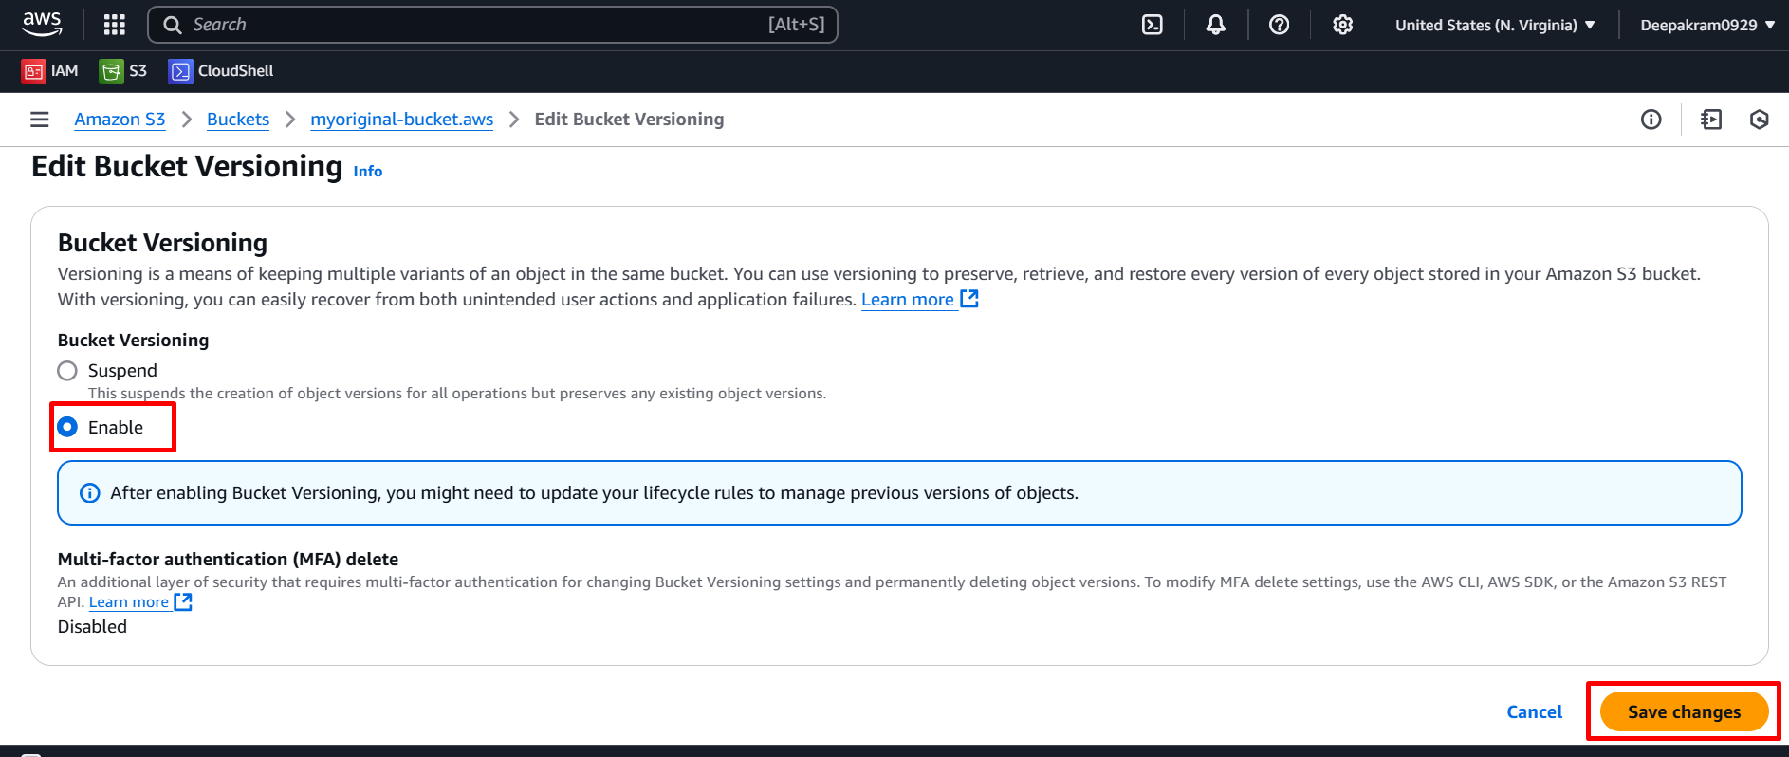

1. **Click on Management** tab in S3 bucket (**myoriginal-bucket.aws**)

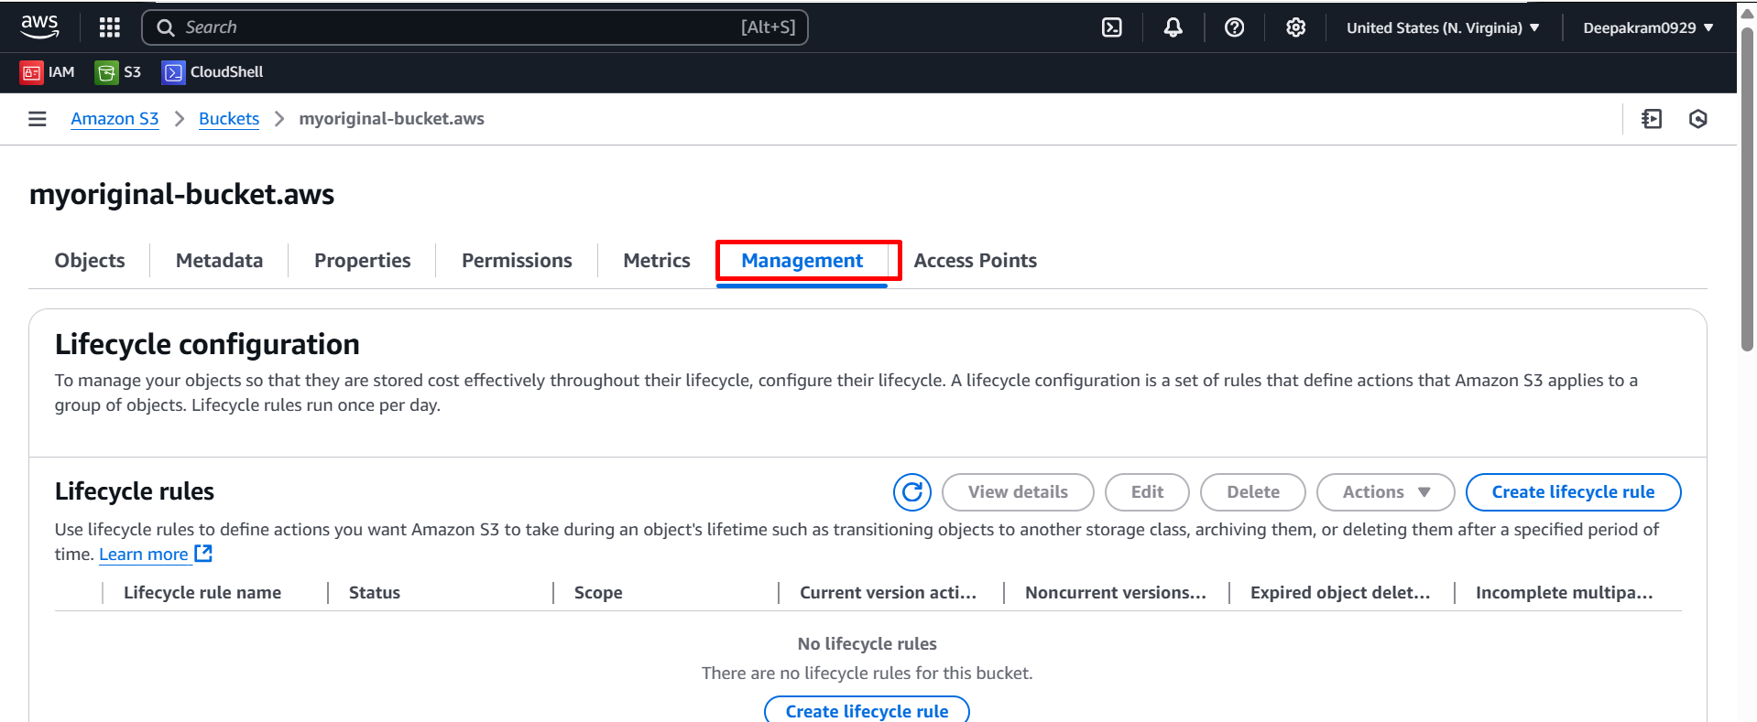

1. **Create replication rule Management** tab in S3 bucket (**myoriginal-bucket.aws**).

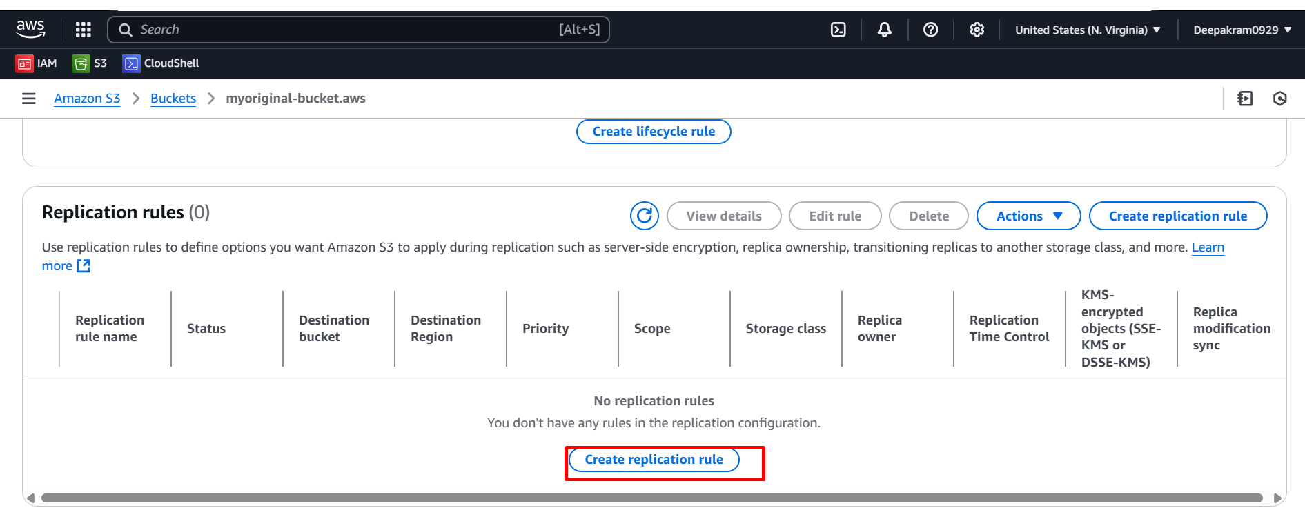

1. Replication rule named **"myreplication-from-original"** is being configured.

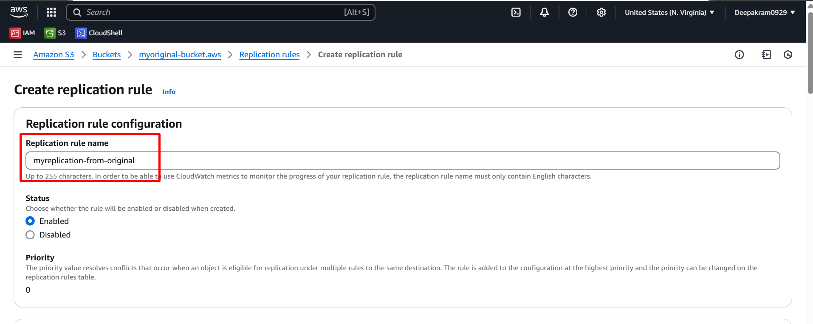

1. configuring an S3 replication rule and have selected **"Apply to all objects in the bucket"** for replication.

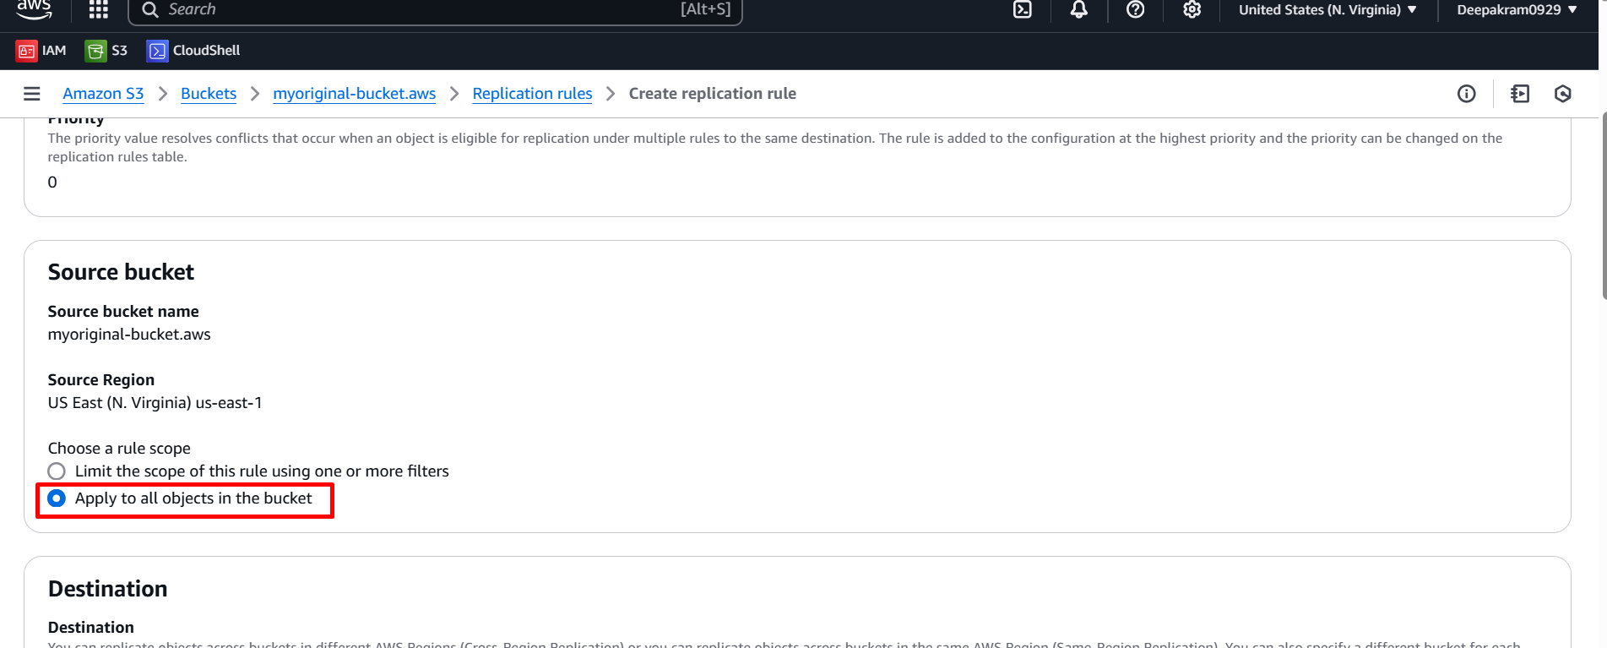

1. Browse s3 bucket for replication

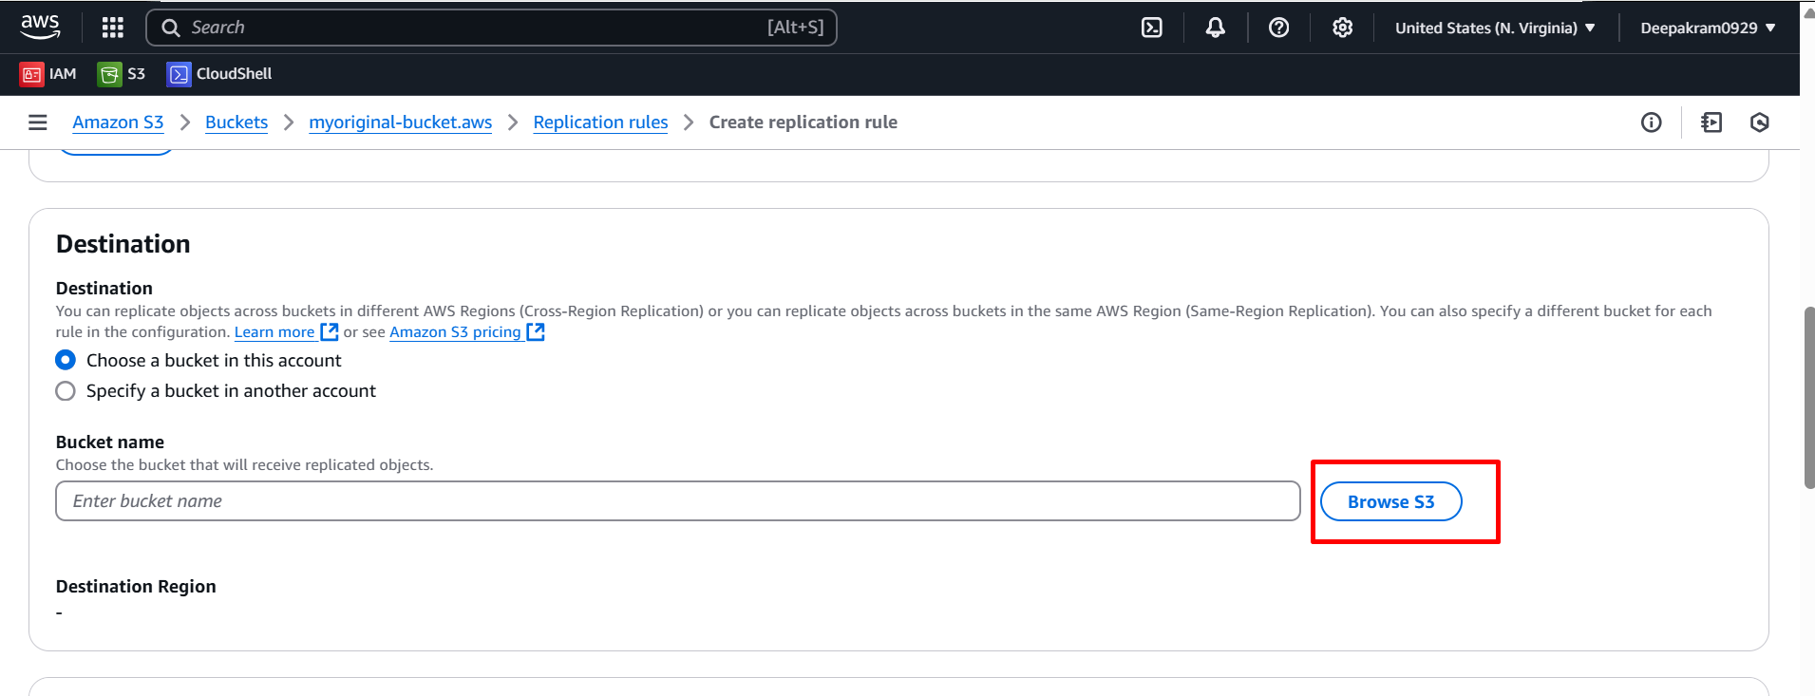

1. Select the destination bucket

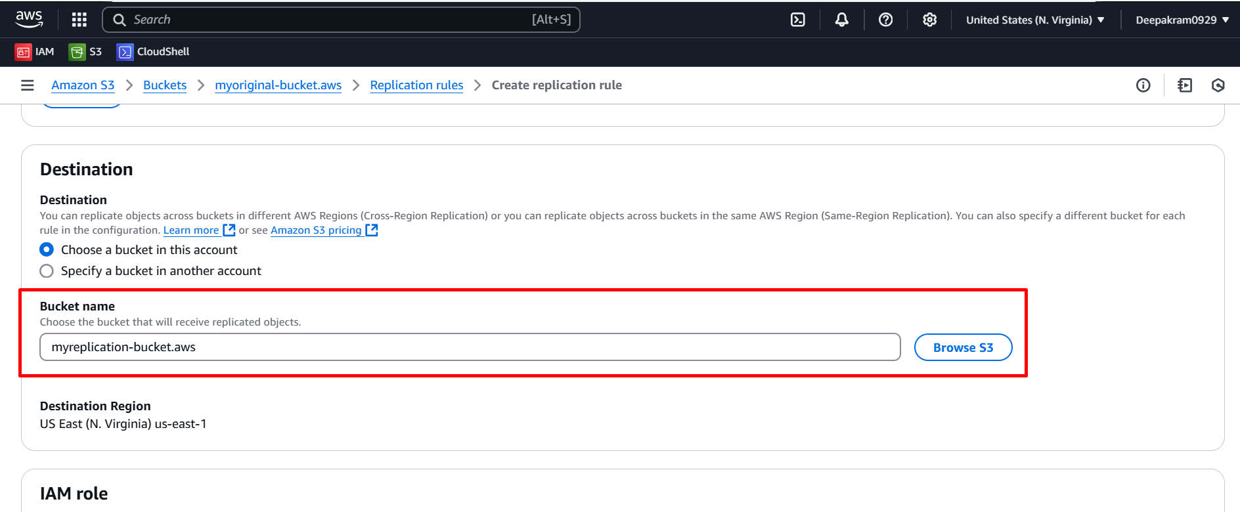

1. **"Create new role"** under the **IAM role** section for your S3 replication rule 🡪save

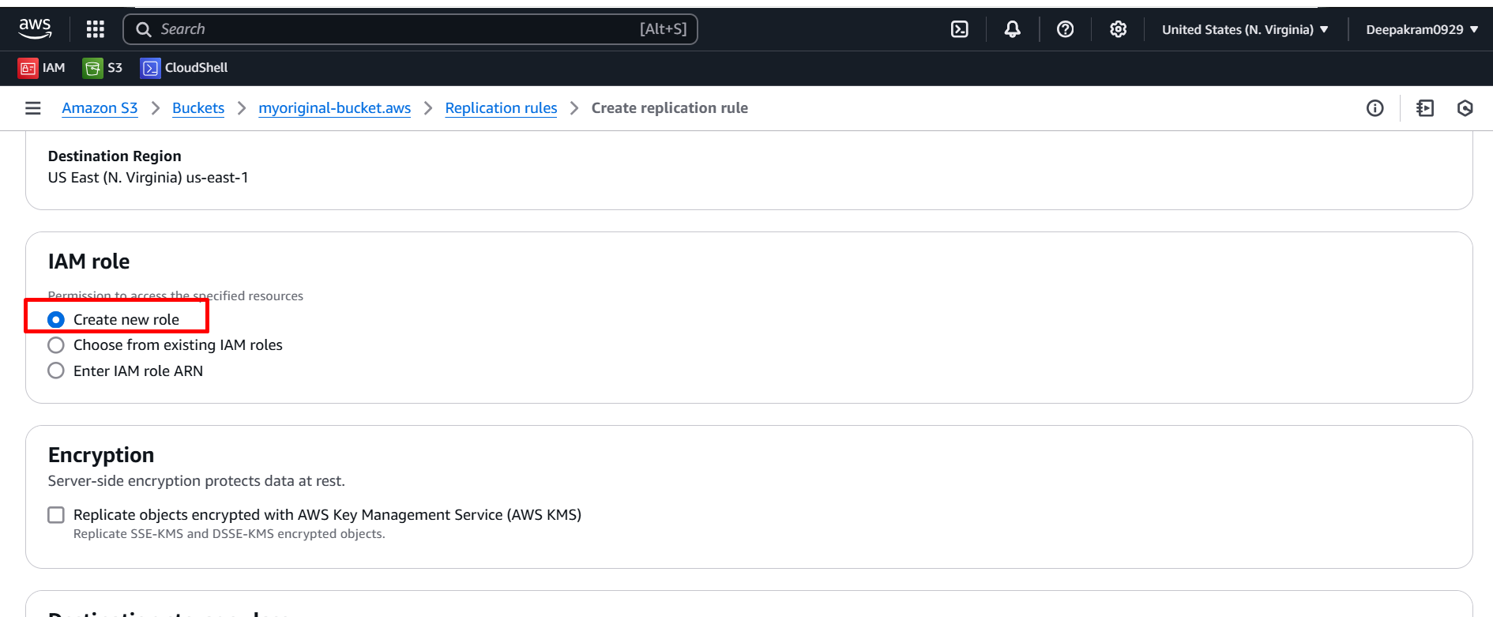

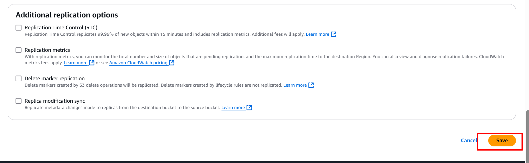

1. **Select "No, do not replicate existing objects"** while setting up your S3 replication rule 🡪submit

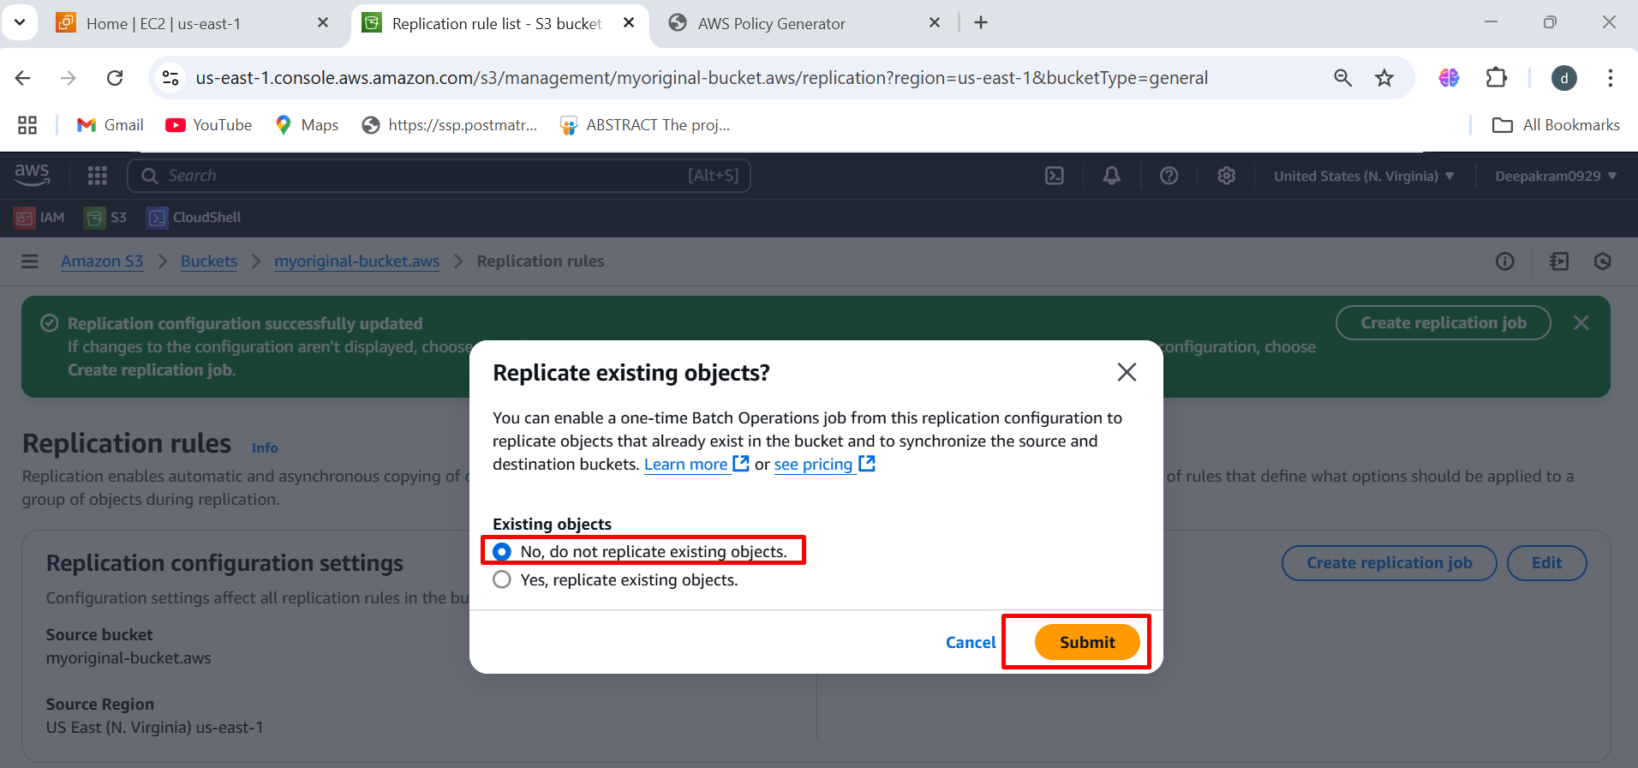

1. Your S3 replication rule **"myreplication-from-original"** has been successfully created and is **enabled**.

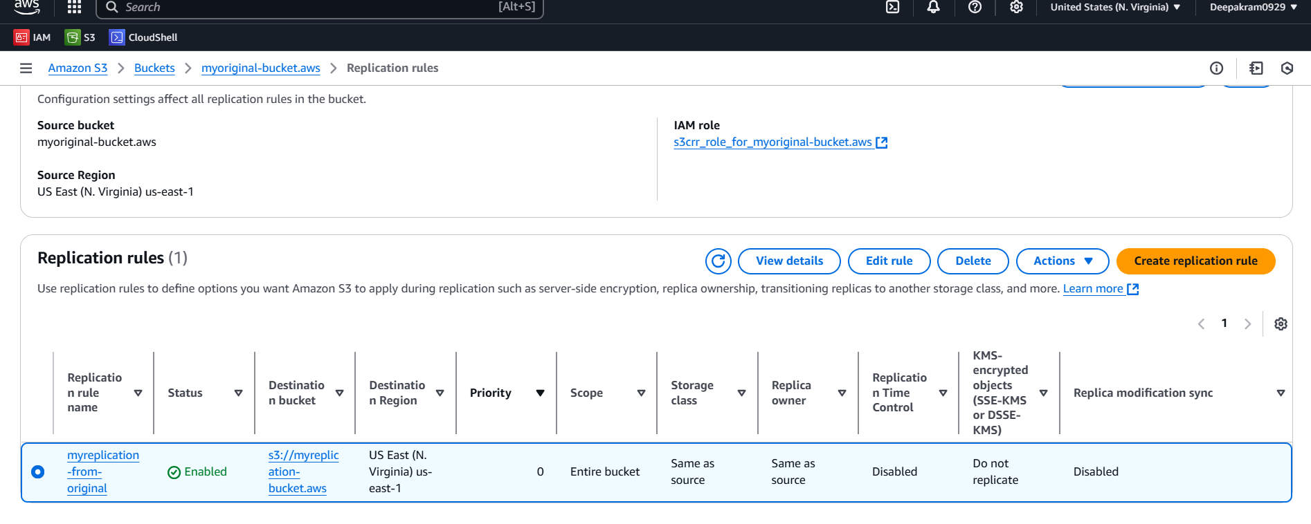

1. **Permissions** tab of your S3 bucket **"myoriginal-bucket.aws"**.

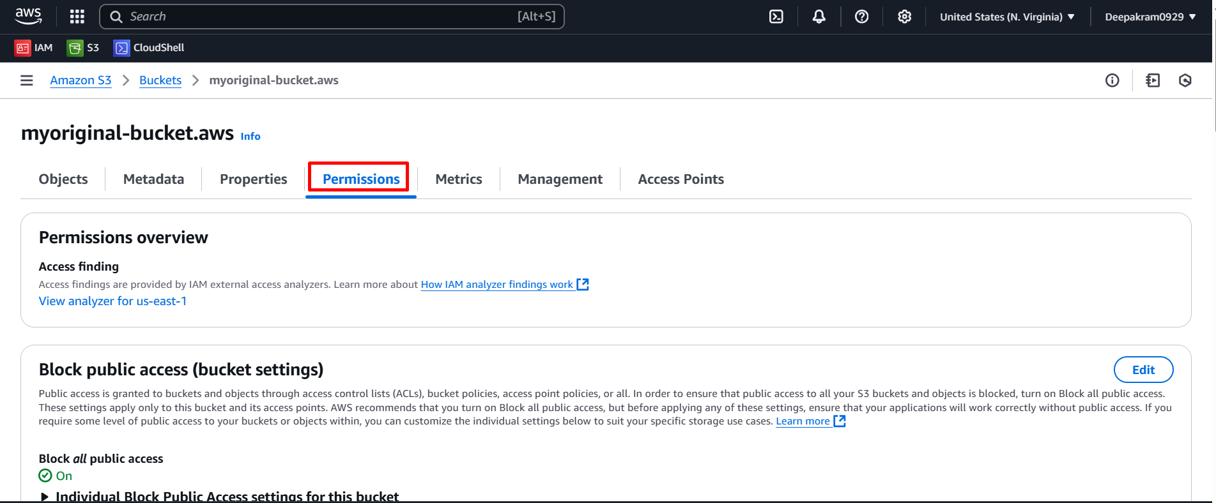

1. **Permissions** tab of your S3 bucket **"myoriginal-bucket.aws"** and have the option to edit the **Block Public Access settings**.

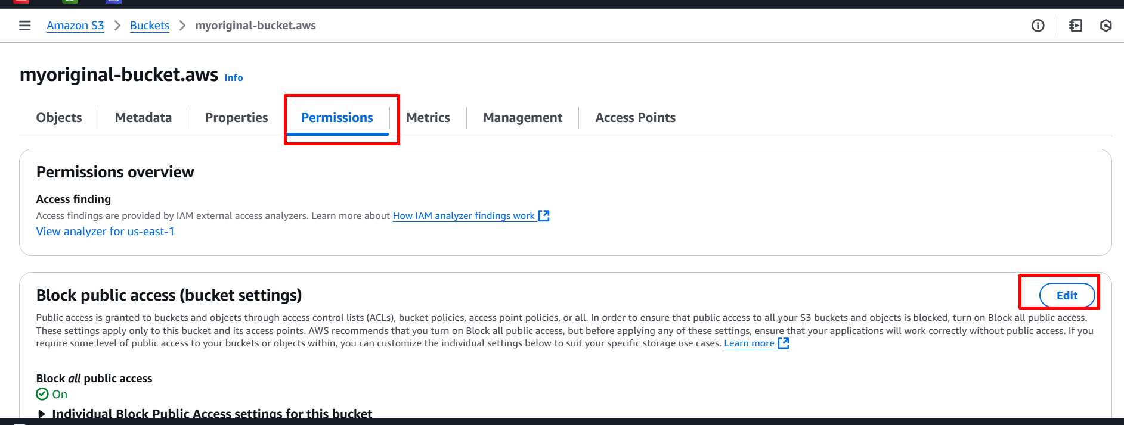

1. Unblock public access 🡪 save changes

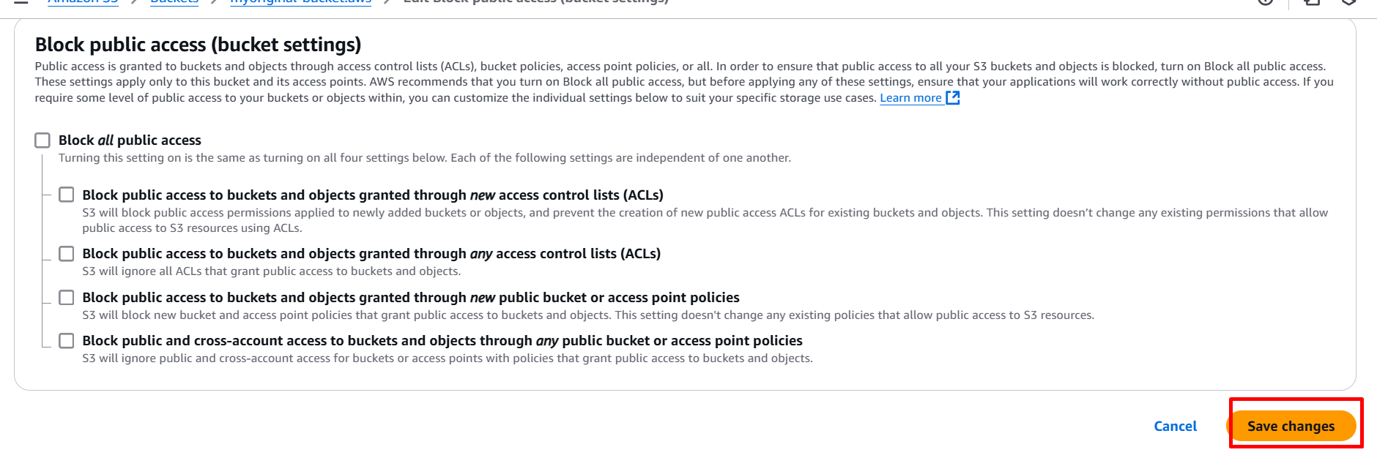

1. Edit the bucket policy 🡪 click on policy generator

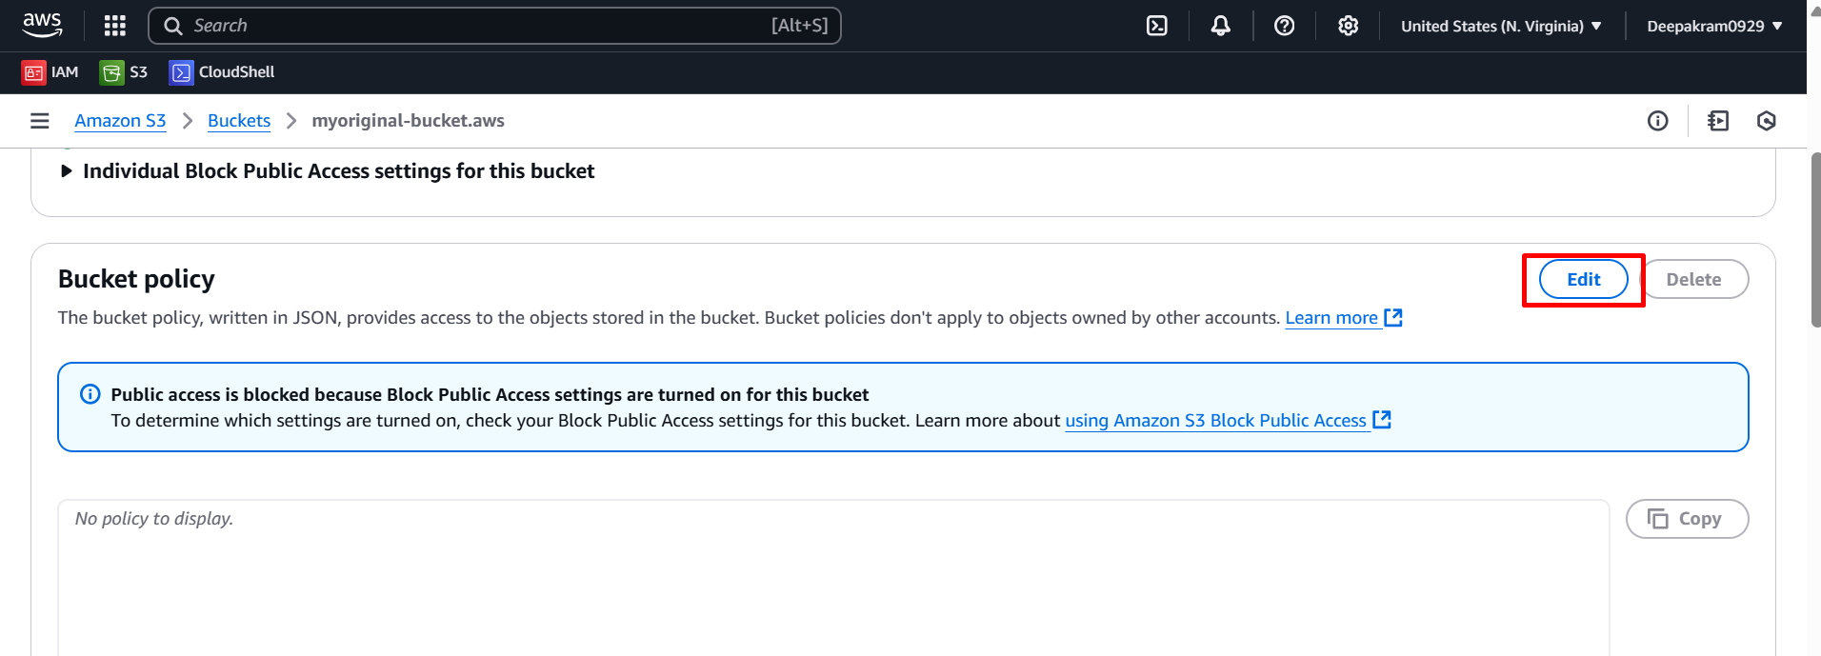

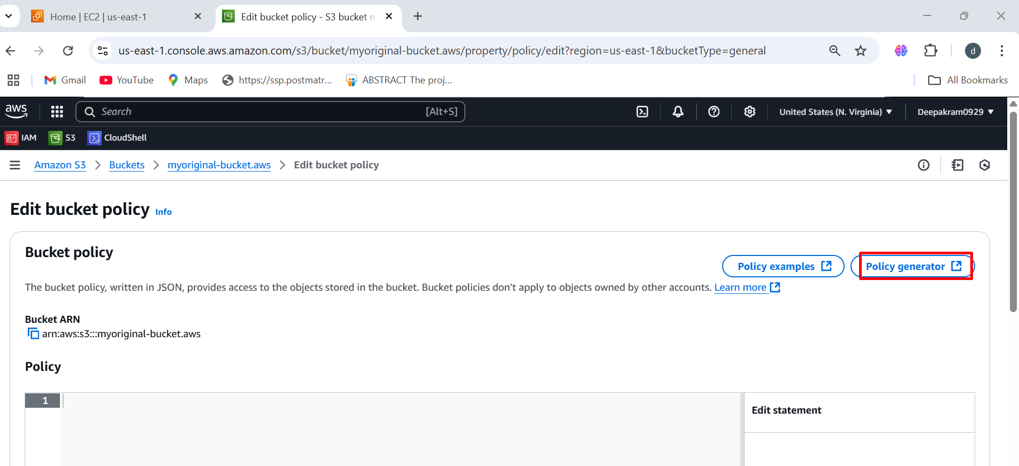

1. **AWS Policy Generator**, a tool used to create JSON-based access policies for AWS services select the policy type 🡪 s3 bucket policy 🡪 Principal *

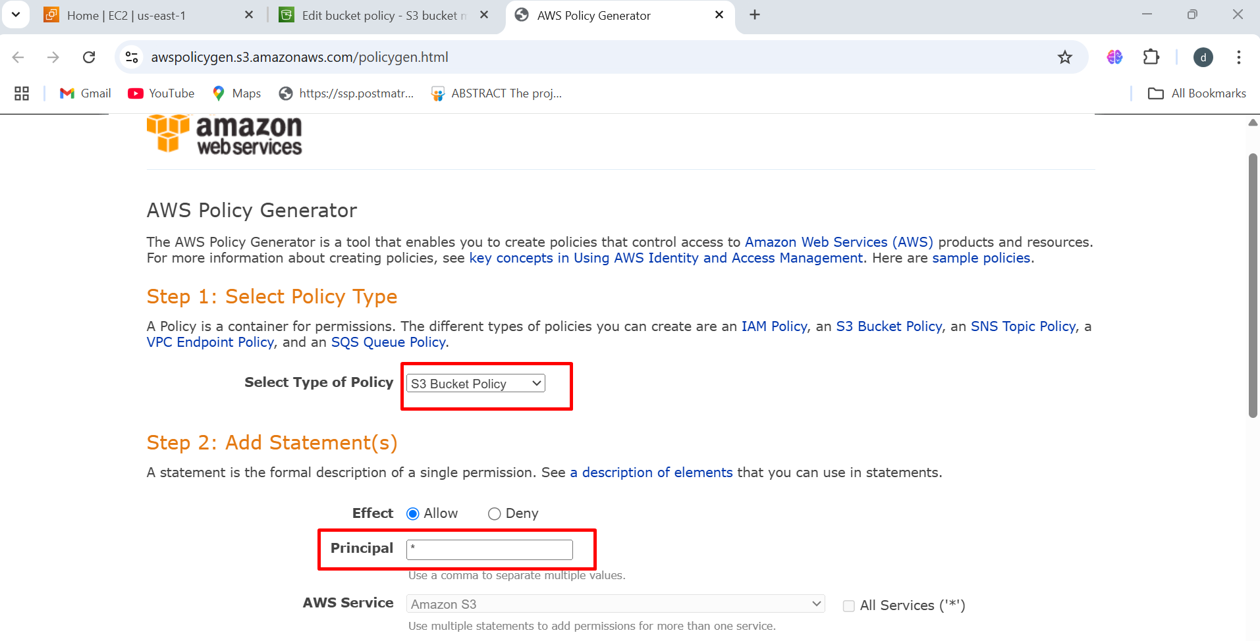

1. The **"GetObject"** action, which allows users to retrieve objects from an S3 bucket.

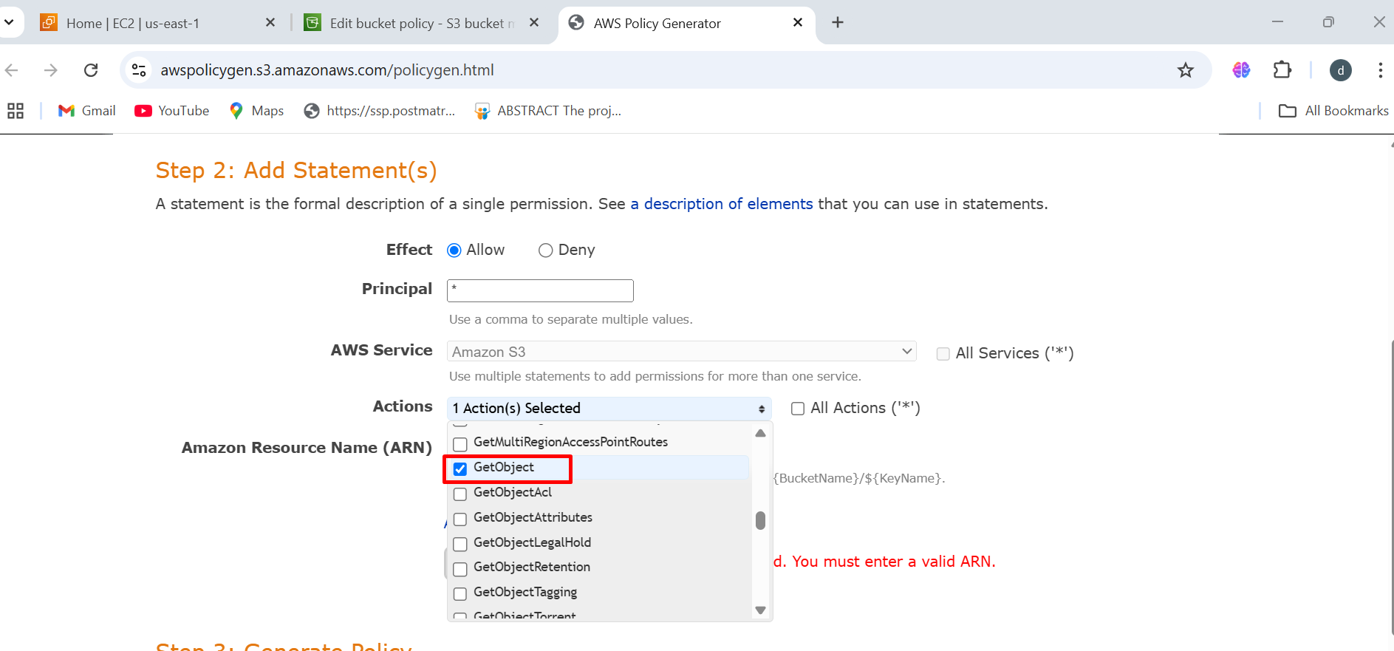

1. **Amazon Resource Name (ARN) 🡪 copy ARN from bucket policy 🡪 paste Amazon Resource Name (ARN)**

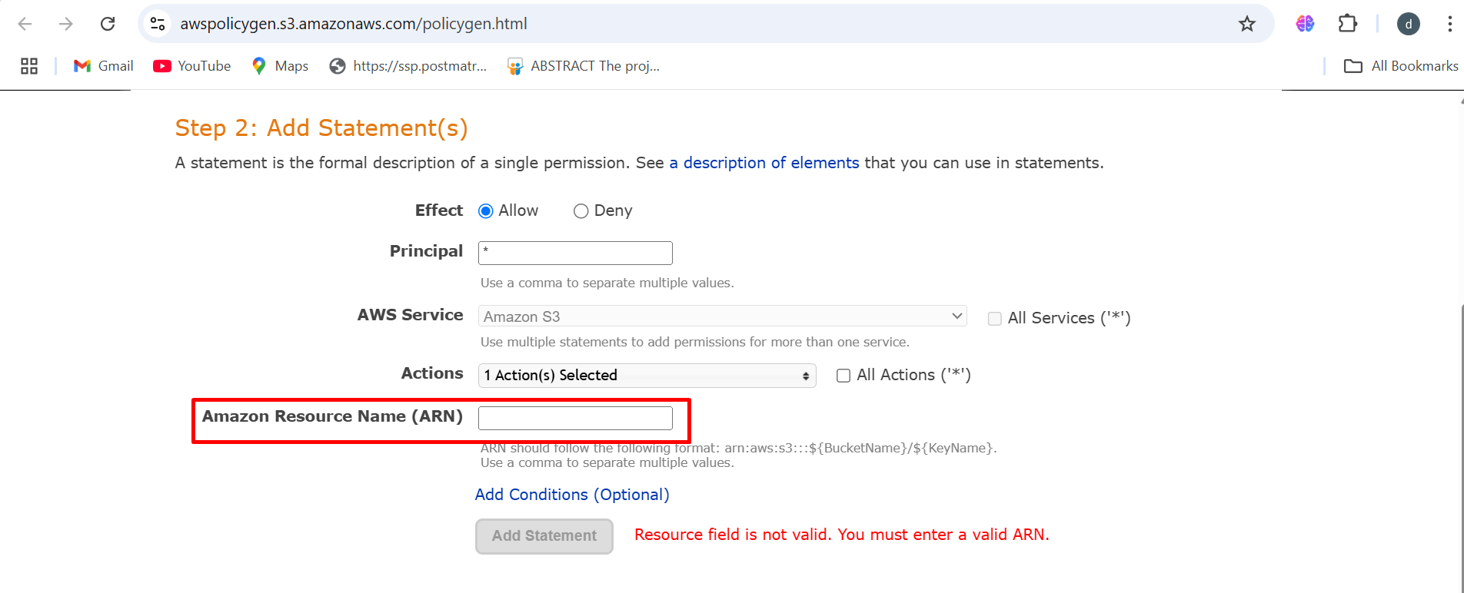

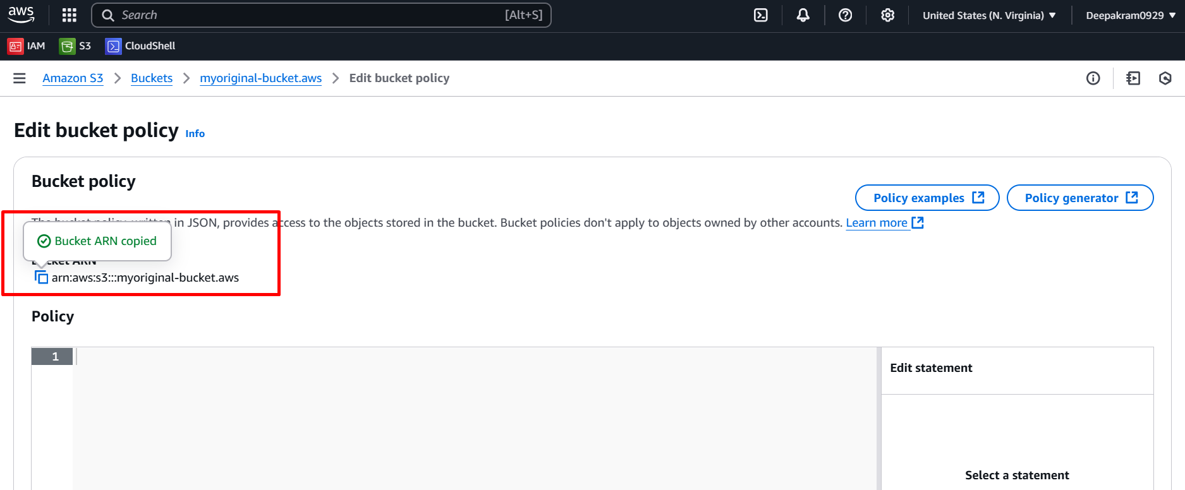

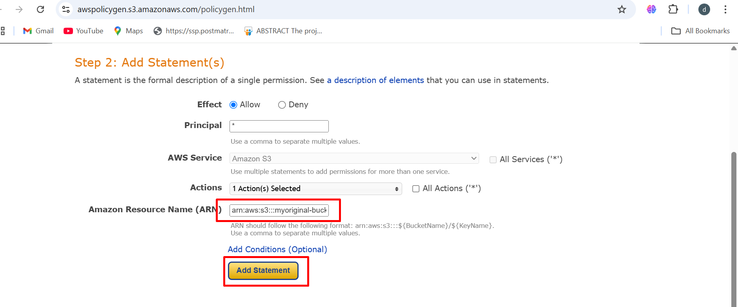

1. Add statement 🡪 click on generate policy 🡪 copy the policy and paste policy to bucket policy

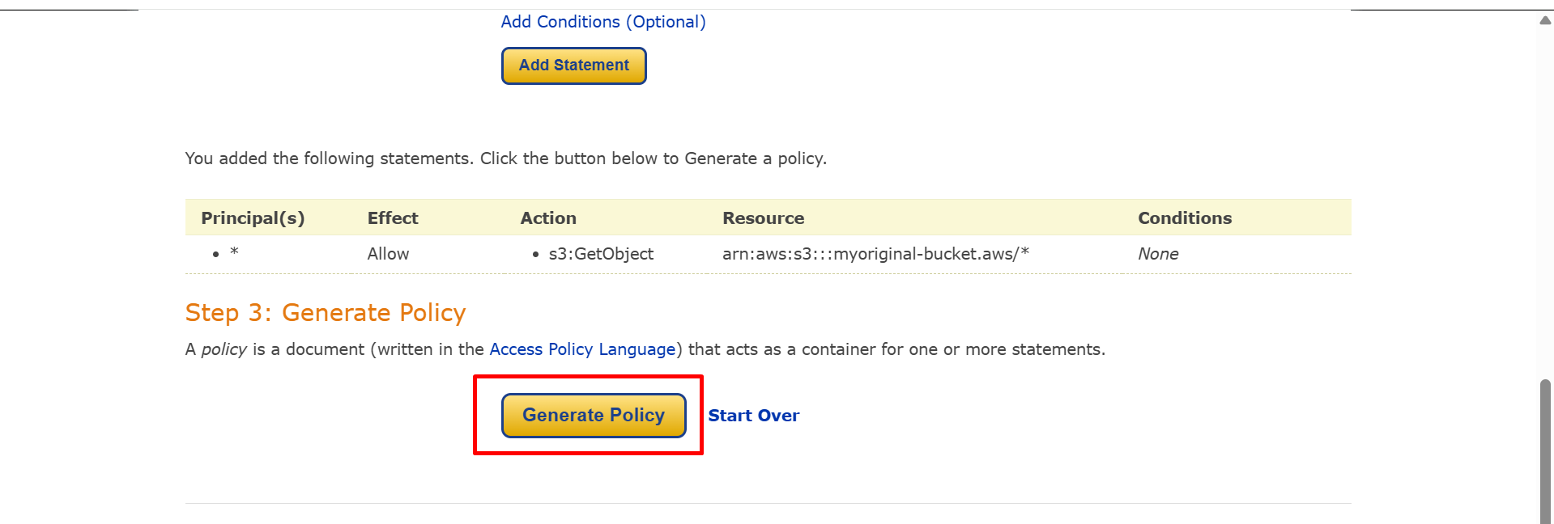

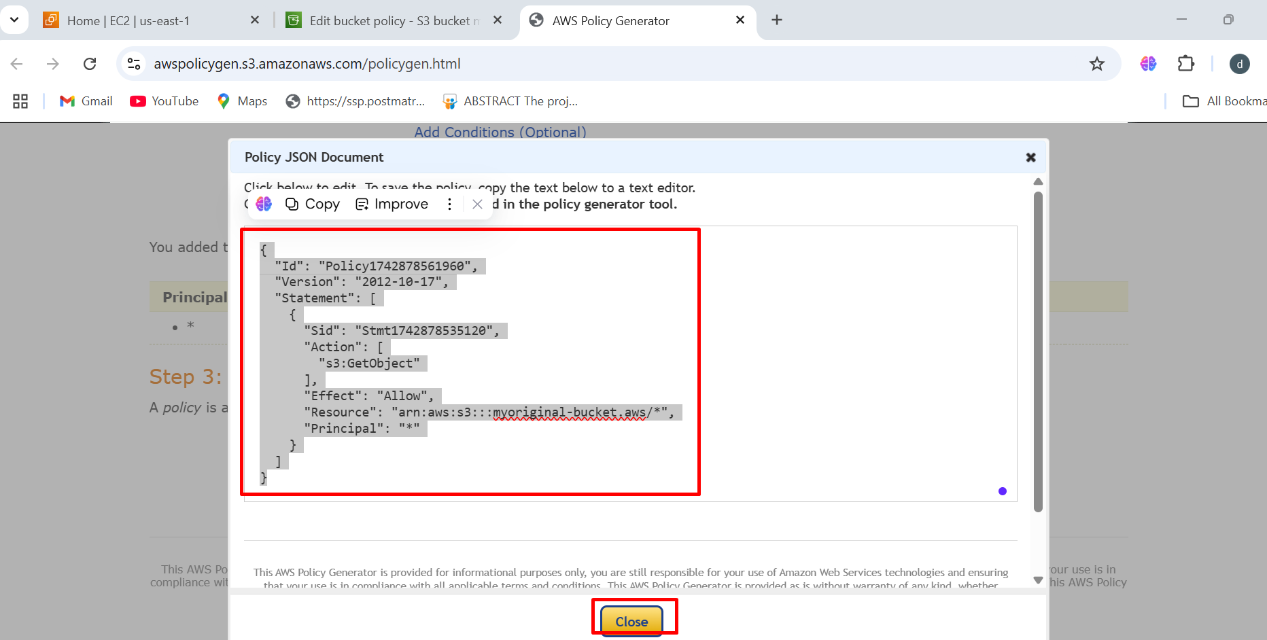

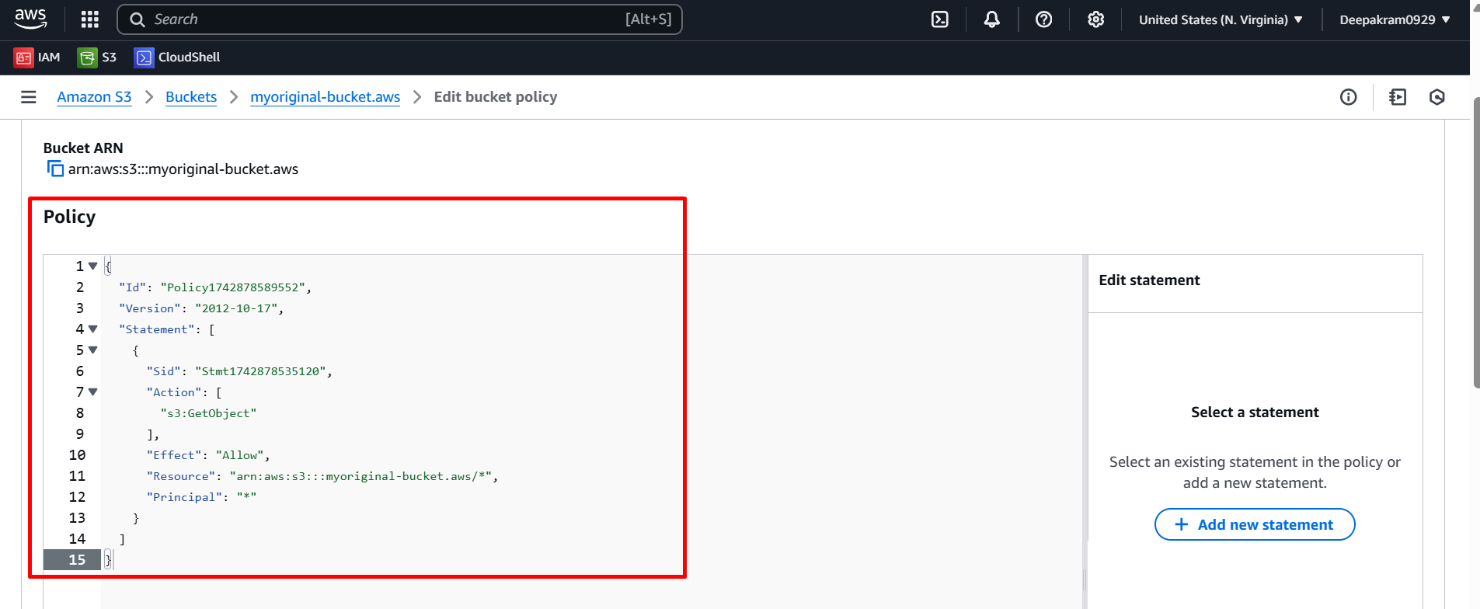

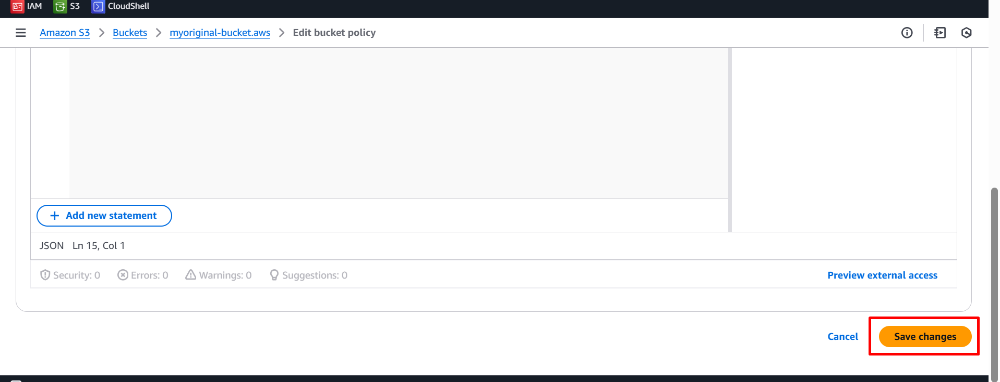

1. Upload some files to origin bucket

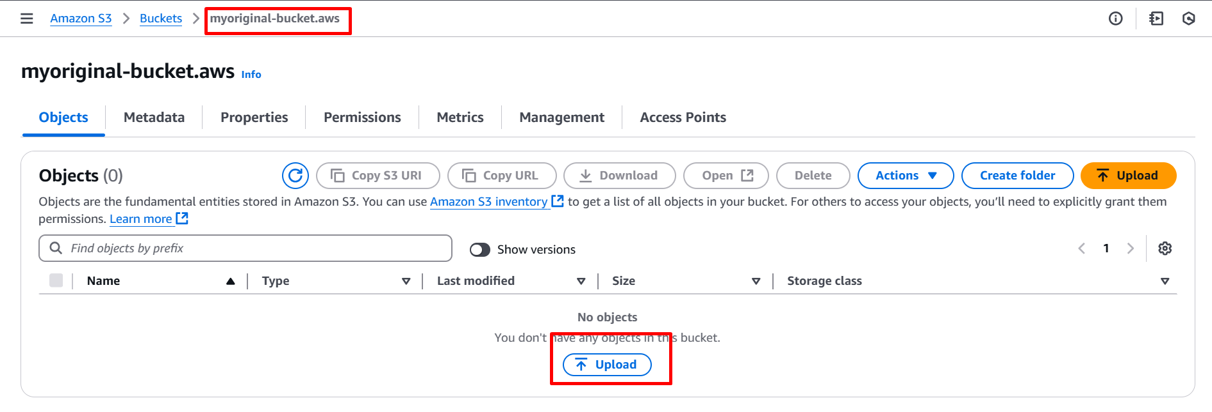

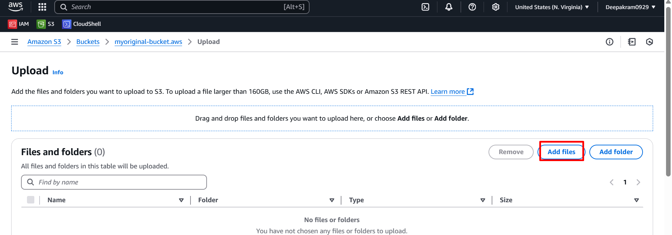

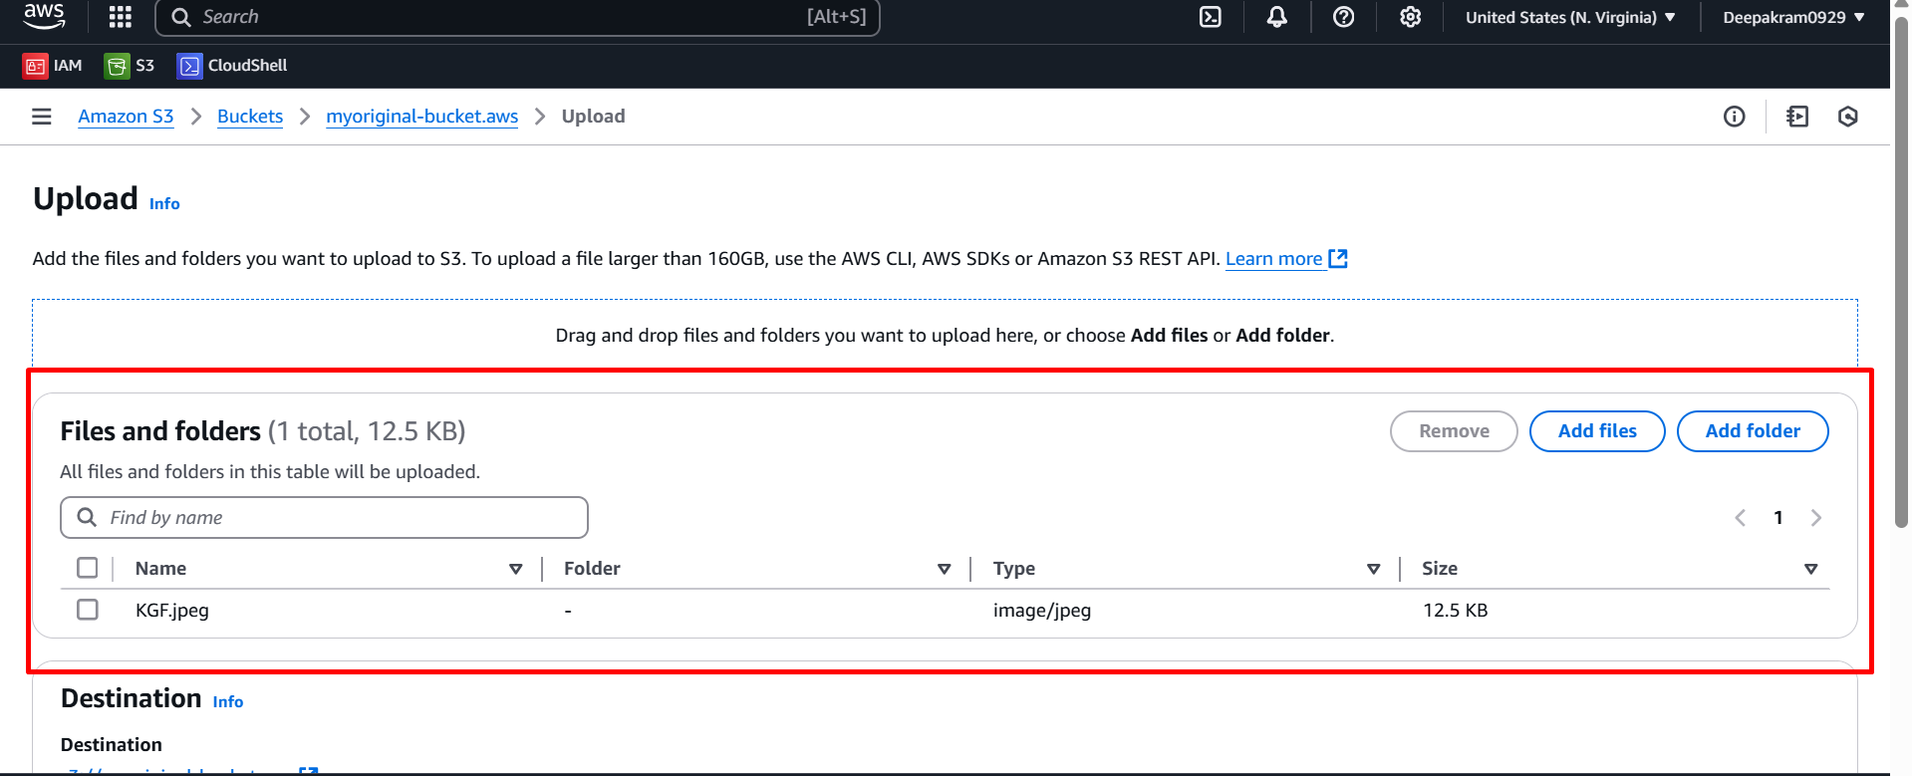

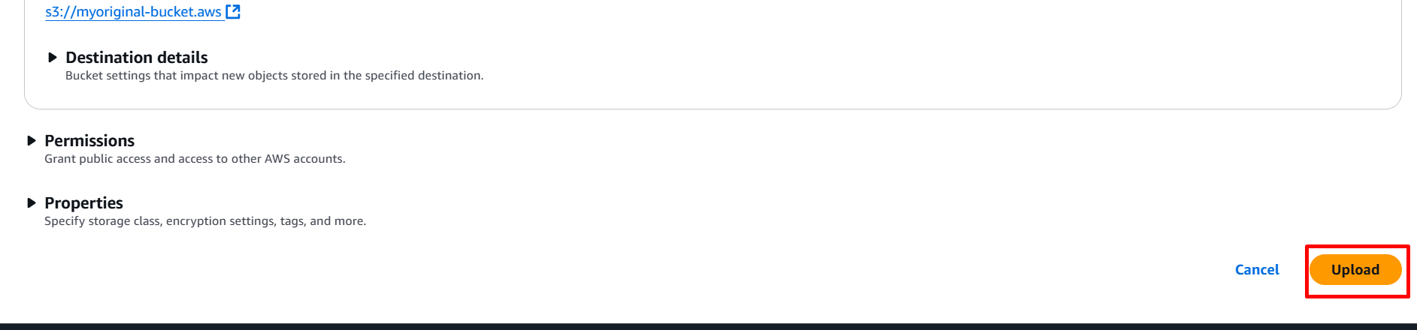

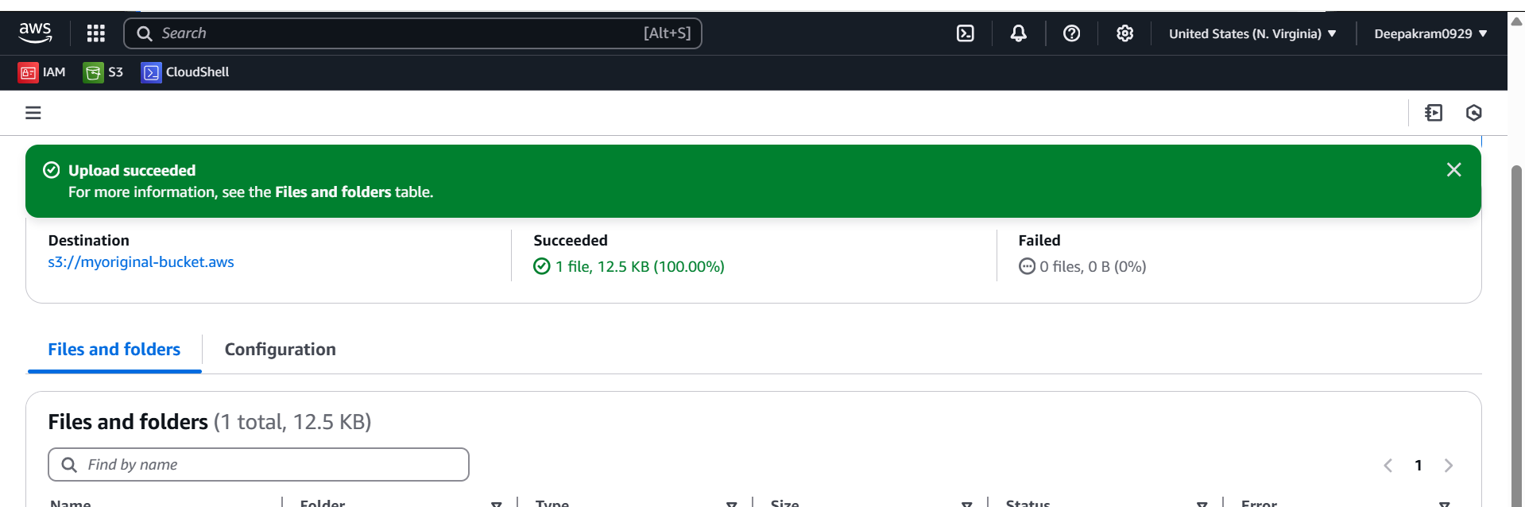

1. Replication of **myoriginal-bucket.aws** bucket file

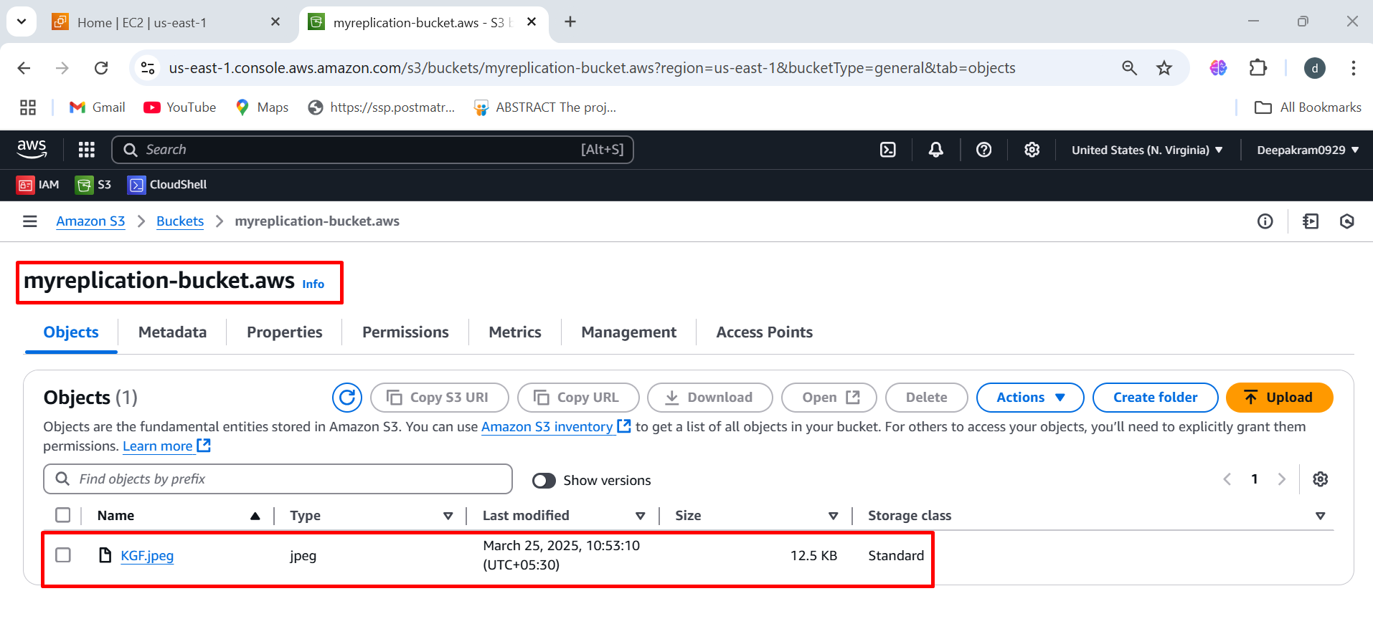

1. **Same steps to replication in different region**

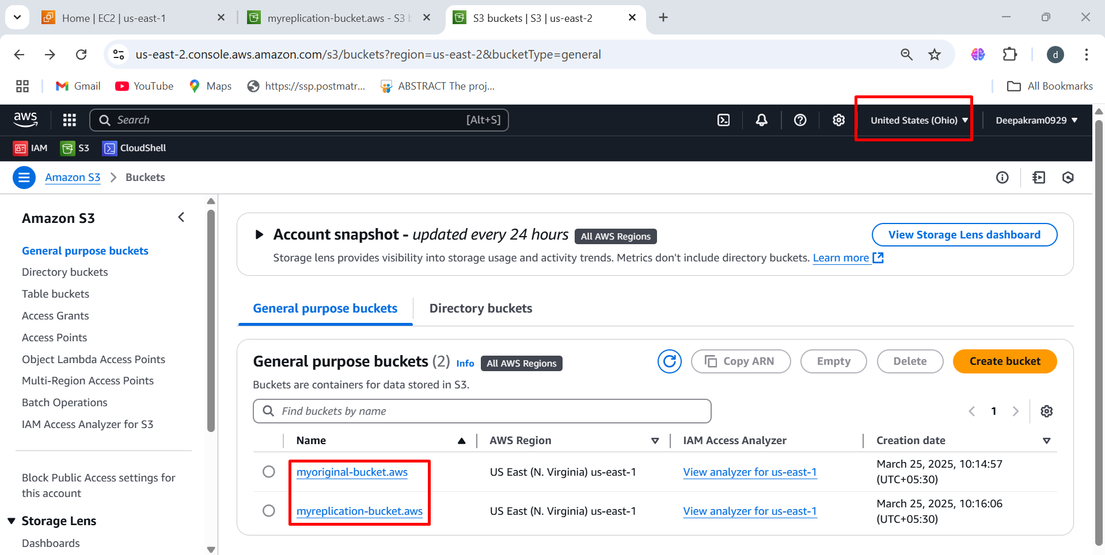

**TO HOST REACT APPLIACTION**

* 1. To create new bucket follow the same steps 🡪 **travel-site-1**

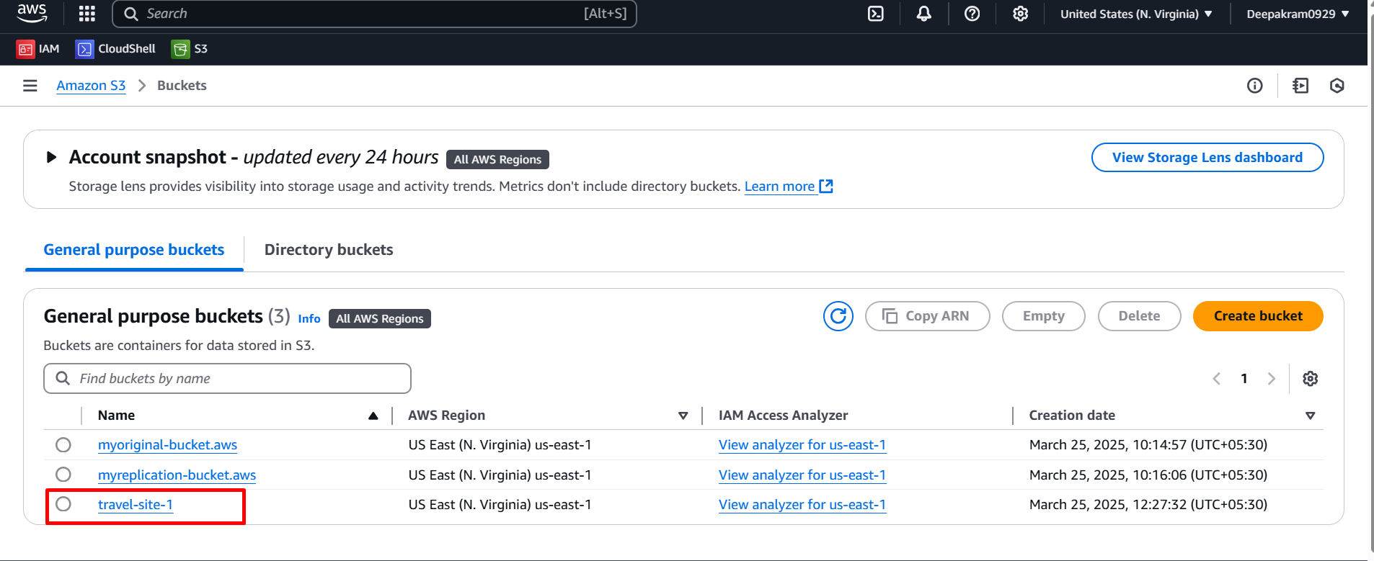

* 1. Under properties 🡪 edit 🡪 enable static web hosting

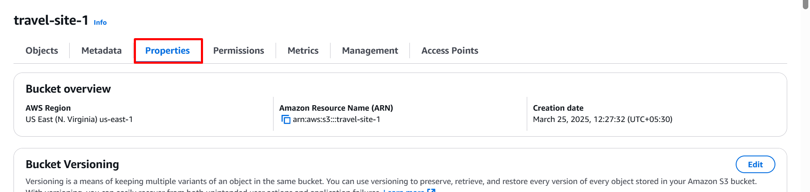

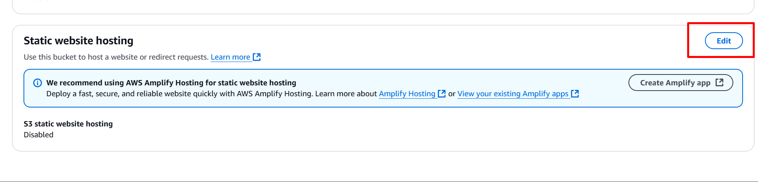

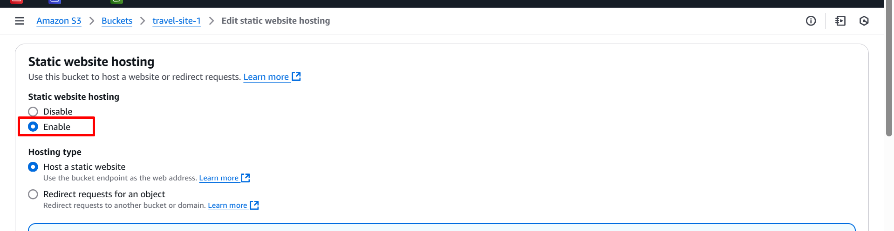

* 1. Provide the index.html static page 🡪 save

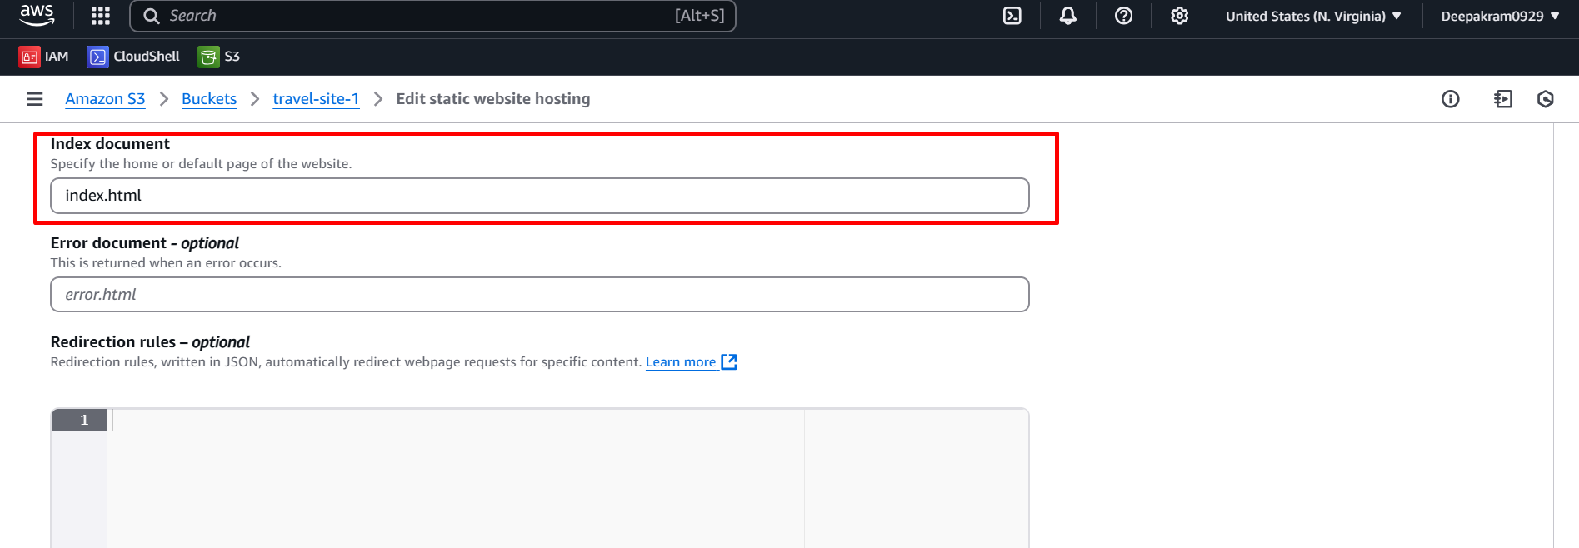

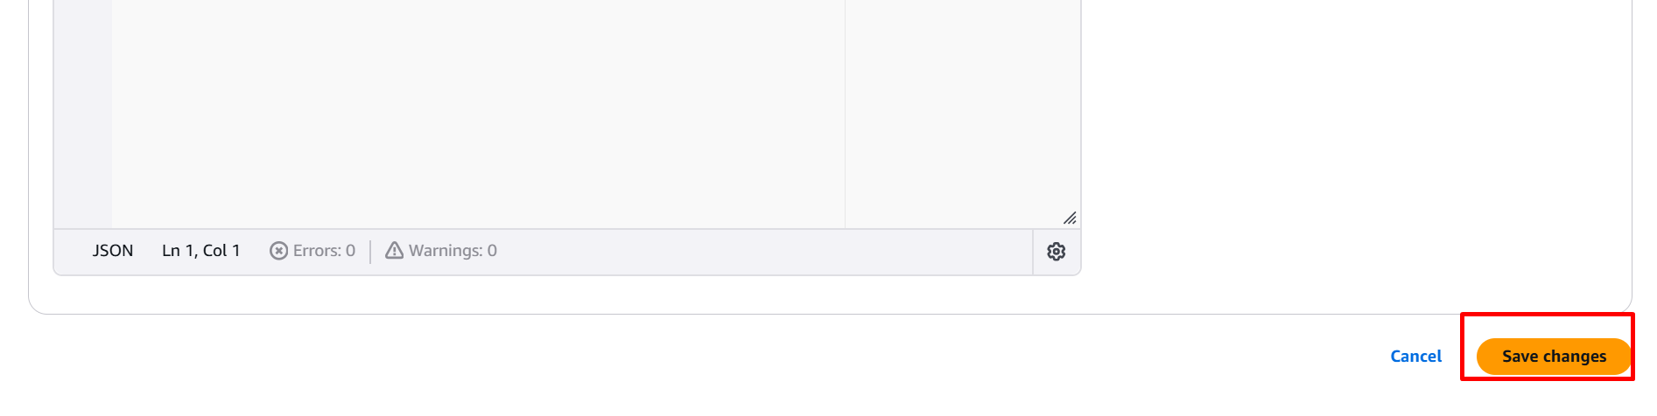

* 1. Bucket policy 🡪 edit 🡪 Click on policy generator

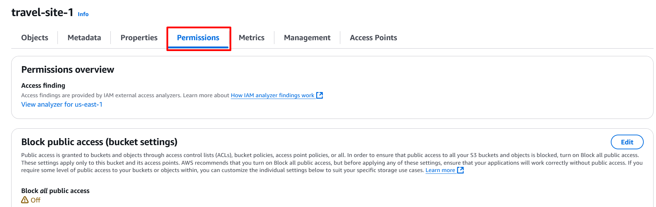

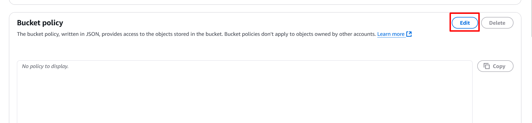

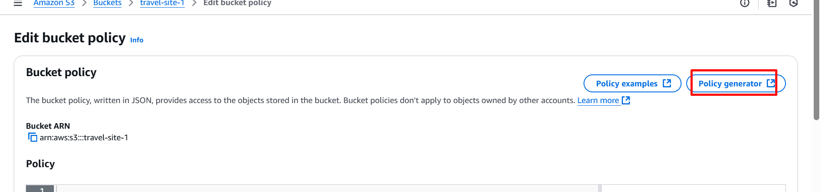

* 1. Paste the JSON policy

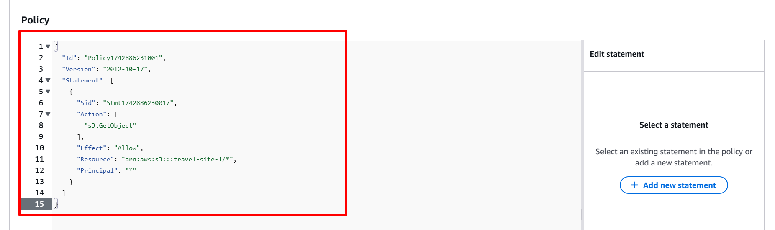

* 1. Open CMD inside folder 🡪 Clone the website

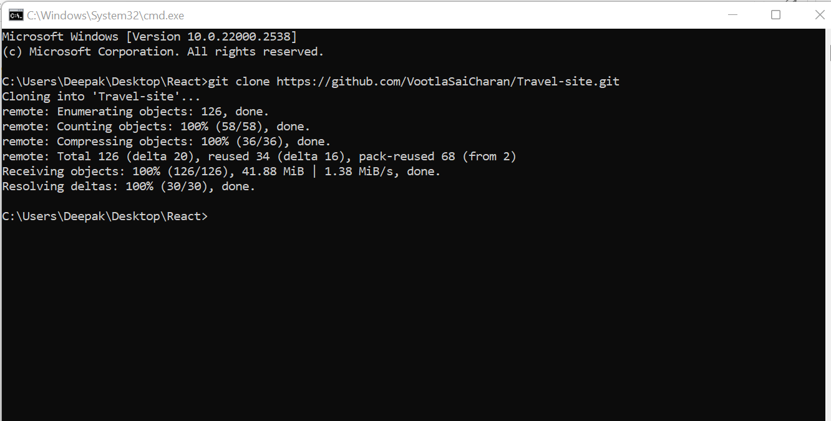

* 1. Enter to travel-site directory 🡪 npm install

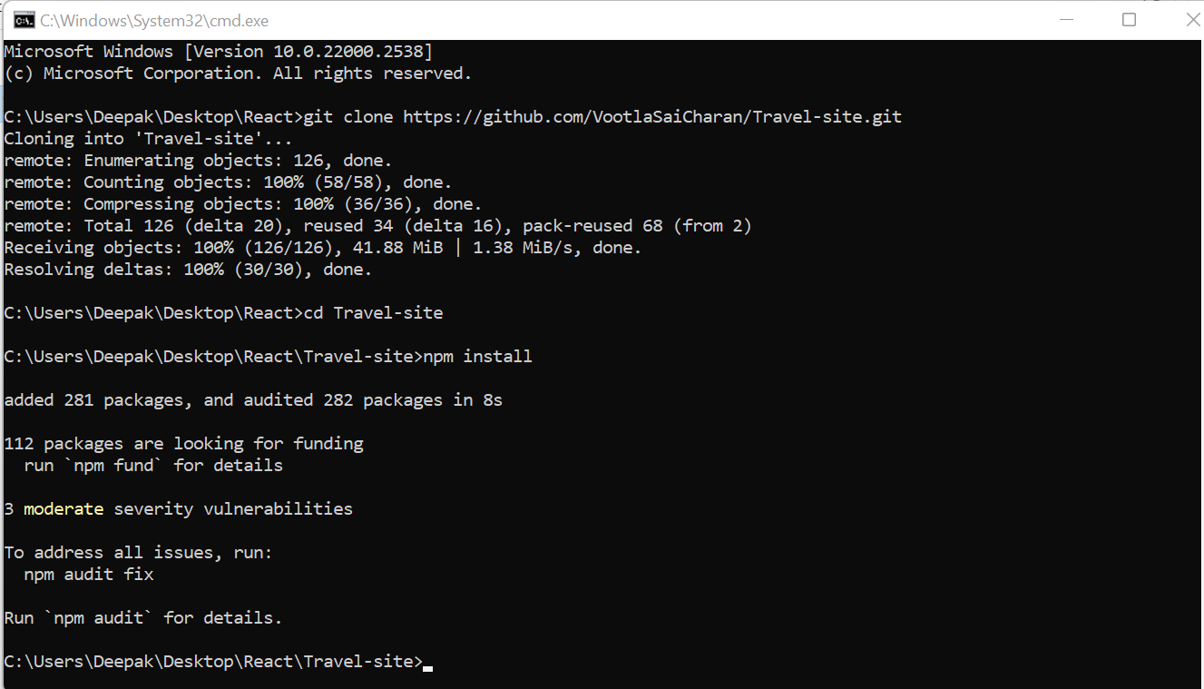

* 1. Build the entire project 🡪 npm run build

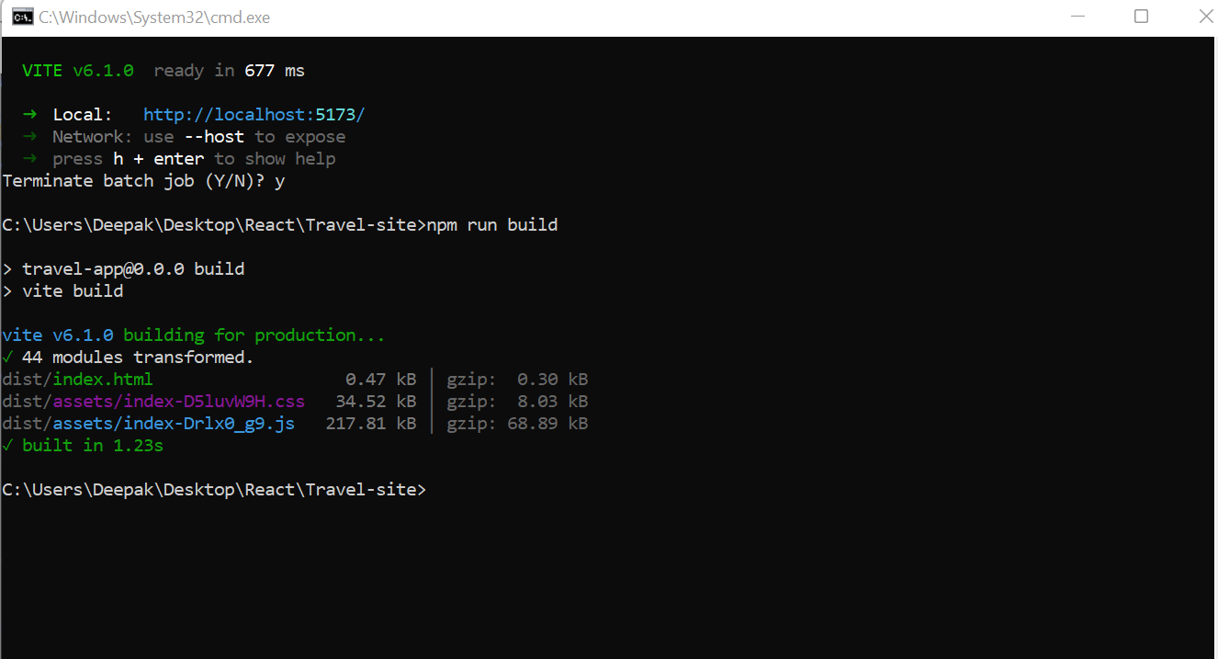

* 1. Upload the Build files named as dist

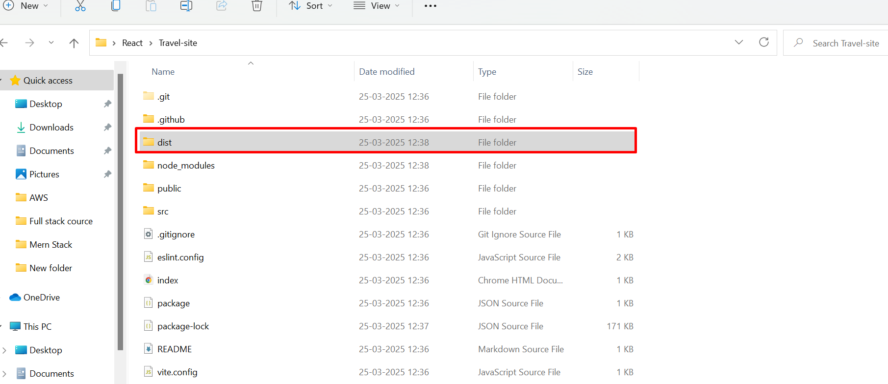

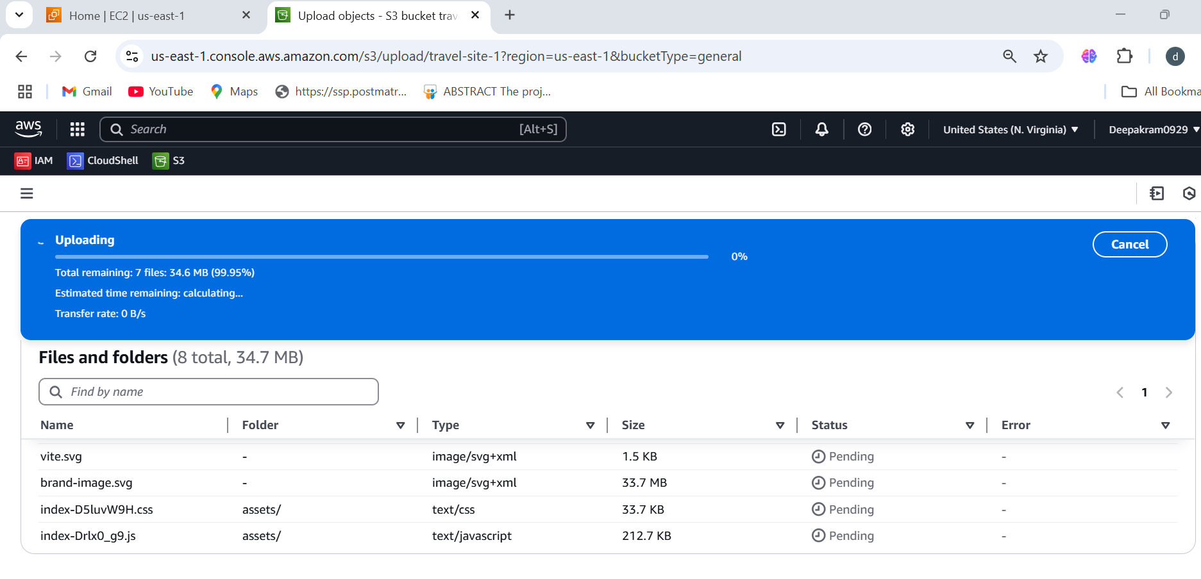

* 1. Files uploaded successfully

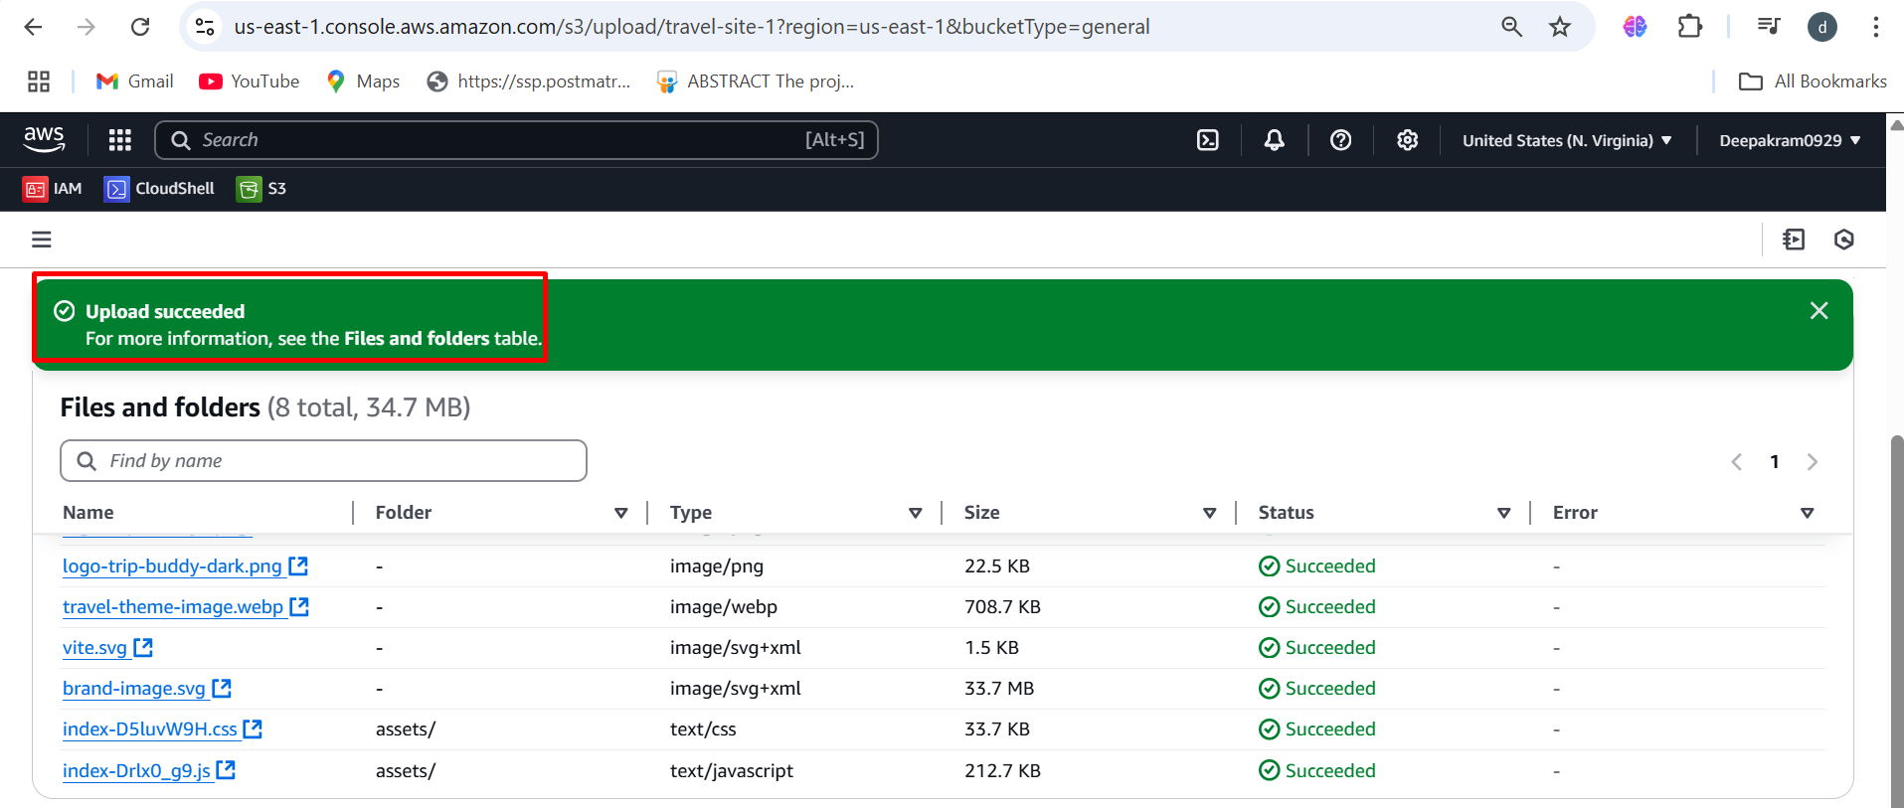

* 1. Output of the travel-site website

